APP SUCCESS PREDICTION ON PLAY STORE

**MACHINE LEARNING PROJECT**

**SUBMITTED BY-**

Keshav -

**Date: 28-11-2018**

# TABLE OF CONTENTS

## Abstract 3

## Introduction 4

## Need of System 4

## Application of Proposed system 4

## Challenges in Development 4

## Working of Proposed system 5

## Data collection & Data Preparation 6

## Training & Testing of model 10

## Results & Discussions 12

## Conclusion 17

## References 18

**ABSTRACT**

This project aims to analyse data about various applications available on Google Play Store. Based on data like application category, size, price, number of installs, content rating, review count , reviews, prediction of how successful an android application will be on the Google Play Store is made. This is achieved by predicting the likely application rating on google play store. For doing this, Linear Regression model, SVM model and Random Forest regression model are used for predicting the rating. Also models are evaluated by comparing the predicted results against the actual results by the use of mean squared error & mean absolute error.

# INTRODUCTION

## NEED OF THE SYSTEM

For developing a good android application, it is better to be aware of the characteristics that makes an application successful on that platform. This system helps one know how well their application will work on Google Play Store based on features of the application and what improvements can be made to make that application a hit on Playstore platform. It will also help developers in improving existing applications to achieve higher customer satisfaction levels and better reviews and ratings on Play Store.

## APPLICATIONS OF PROPOSED SYSTEM

* It can be used to predict rating of an application available on Google Play Store, based on current ratings of other applications.
* It can be used to predict the success of a new application on Google Play Store. One can simply add this new application’s details in the testing set and get the results.

## CHALLENGES IN DEVELOPMENT

* The columns ‘category’ and ‘genre’ store almost the same data. If two explanatory variables in a model are highly linearly related, it poses a problem called multicollinearity. Together, these columns have nearly the same effect on the final result. So considering them both can affect the result. Therefore, we dropped ‘genre’ column from the dataset.
* The dataset contained columns like ‘Last Updated’, ‘Current version’, ‘Android Version’, which do not play any part in the app ratings on Play Store. So we dropped these columns by using dataset.drop (labels=[]) function.
* In data preprocessing stage, an error was incurred because of the rows which had NULL values. Thus, we applied ‘dataset.dropna()’ function to remove the rows which had NULL values in them.
* We encountered an error of approximately 65% while using SVM model. It was so because we were initially performing feature scaling in SVM model. We overcame this error by removing feature scaling and re-applying the model. Without feature scaling, an error of approximately 20% was there.

# WORKING OF PROPOSED SYSTEM

Proposed system uses Machine learning algorithms to predict the rating of the application of google play store based on their features. Branch of Machine learning used here is supervised Learning which needs a human to “supervise” and tell the computer what it should be trained to predict for, or give it the right answer. We feed the computer with training data containing various features, and we also tell it the right answer. Supervised learning can solve two problems- Classification & Regression. For the said problem, regression is used so as to predict application rating. Machine learning problem in supervised learning can be solved in three stages which are - Data Preparation, Training & Testing, & evaluation of used models.

For the regression problem, most commonly used regression models are used which are - Linear Regression, SVM Model & Random forest regression model.

Linear regression is the simplest of regression model which is a linear approach to modelling the relationship between a scalar response (or dependent variable) and one or more explanatory variables (or independent variables). Support vector machines (SVMs, also support vector networks[[1]](https://en.wikipedia.org/wiki/Support_vector_machine#cite_note-CorinnaCortes-1)) are supervised learning models with associated learning algorithms that analyze data used for classification and regression analysis. When used alone, decision trees are prone to overfitting. However, random forests help by correcting the possible overfitting that could occur. Random forests work by using multiple decision trees — using a multitude of different decision trees with different predictions, a random forest combines the results of those individual trees to give the final outcomes.

# DATA COLLECTION AND DATA PREPARATION

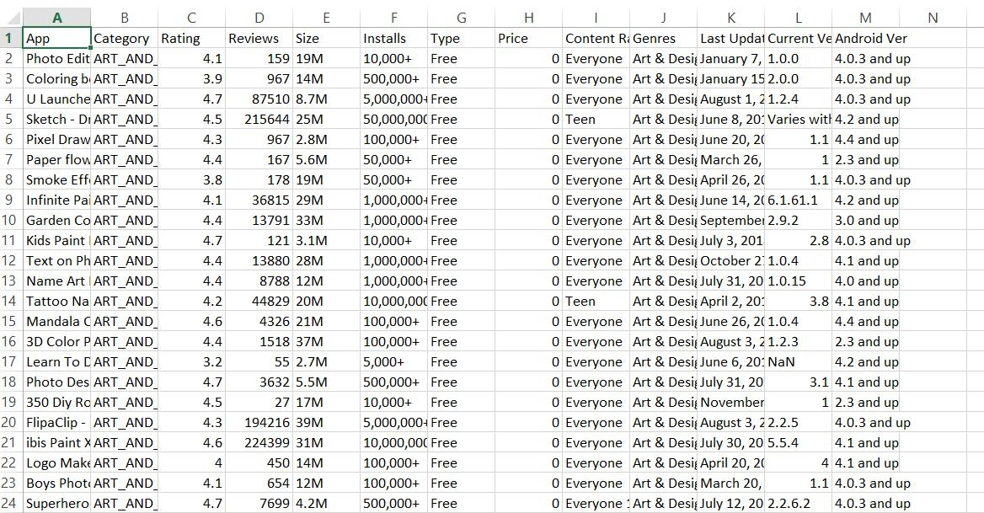Dataset for the said problem was collected from Kaggle & contains columns as shown-

Columns in the dataset are explained-

* App

Application name

* Category

Category the app belongs to

* Rating

Overall user rating of the app

* Reviews

Number of user reviews for the app

* Size

Size of the app

* Installs

Number of user downloads/installs for the app

* Type

Paid or Free

* Price

Price of the app

* Content Rating

Age group the app is targeted at - Children / Mature 21+ / Adult

* Genres

An app can belong to multiple genres

* Last Updated

Date when the app was last updated on Play Store

* Current Ver

Current version of the app available on Play Store

* Android Ver

Min required Android version

**import** **pandas** **as** **pd**

In [7]:

**import** **numpy** **as** **np**

In [8]:

df=pd.read_csv('googleplaystore.csv')

In [9]:

df.head()

Out[9]:

|  | **App** | **Category** | **Rating** | **Reviews** | **Size** | **Installs** | **Type** | **Price** | **Content Rating** | **Genres** | **Last Updated** | **Current Ver** | **Android Ver** |
| --- | --- | --- | --- | --- | --- | --- | --- | --- | --- | --- | --- | --- | --- |
| **0** | Photo Editor & Candy Camera & Grid & ScrapBook | ART_AND_DESIGN | 4.1 | 159 | 19M | 10,000+ | Free | 0 | Everyone | Art & Design | January 7, 2018 | 1.0.0 | 4.0.3 and up |
| **1** | Coloring book moana | ART_AND_DESIGN | 3.9 | 967 | 14M | 500,000+ | Free | 0 | Everyone | Art & Design;Pretend Play | January 15, 2018 | 2.0.0 | 4.0.3 and up |
| **2** | U Launcher Lite – FREE Live Cool Themes, Hide ... | ART_AND_DESIGN | 4.7 | 87510 | 8.7M | 5,000,000+ | Free | 0 | Everyone | Art & Design | August 1, 2018 | 1.2.4 | 4.0.3 and up |
| **3** | Sketch - Draw & Paint | ART_AND_DESIGN | 4.5 | 215644 | 25M | 50,000,000+ | Free | 0 | Teen | Art & Design | June 8, 2018 | Varies with device | 4.2 and up |
| **4** | Pixel Draw - Number Art Coloring Book | ART_AND_DESIGN | 4.3 | 967 | 2.8M | 100,000+ | Free | 0 | Everyone | Art & Design;Creativity | June 20, 2018 | 1.1 | 4.4 and up |

In [10]:

df.shape

Out[10]:

(10841, 13)

In [11]:

*#Check for null values in the data. Get the number of null values for each column.*

In [12]:

df.isnull().sum()

Out[12]:

App 0

Category 0

Rating 1474

Reviews 0

Size 0

Installs 0

Type 1

Price 0

Content Rating 1

Genres 0

Last Updated 0

Current Ver 8

Android Ver 3

dtype: int64

In [13]:

*#Drop records with nulls in any of the columns.*

In [14]:

df=df.dropna()

In [15]:

df.shape

Out[15]:

(9360, 13)

In [16]:

df.info()

<class 'pandas.core.frame.DataFrame'>

Int64Index: 9360 entries, 0 to 10840

Data columns (total 13 columns):

# Column Non-Null Count Dtype

--- ------ -------------- -----

0 App 9360 non-null object

1 Category 9360 non-null object

2 Rating 9360 non-null float64

3 Reviews 9360 non-null object

4 Size 9360 non-null object

5 Installs 9360 non-null object

6 Type 9360 non-null object

7 Price 9360 non-null object

8 Content Rating 9360 non-null object

9 Genres 9360 non-null object

10 Last Updated 9360 non-null object

11 Current Ver 9360 non-null object

12 Android Ver 9360 non-null object

dtypes: float64(1), object(12)

memory usage: 1023.8+ KB

In [17]:

*#Variables seem to have incorrect type and inconsistent formatting. You need to fix them:*

In [18]:

df['Reviews']=df['Reviews'].astype("int64")

In [19]:

df.tail()

Out[19]:

|  | **App** | **Category** | **Rating** | **Reviews** | **Size** | **Installs** | **Type** | **Price** | **Content Rating** | **Genres** | **Last Updated** | **Current Ver** | **Android Ver** |
| --- | --- | --- | --- | --- | --- | --- | --- | --- | --- | --- | --- | --- | --- |
| **10834** | FR Calculator | FAMILY | 4.0 | 7 | 2.6M | 500+ | Free | 0 | Everyone | Education | June 18, 2017 | 1.0.0 | 4.1 and up |
| **10836** | Sya9a Maroc - FR | FAMILY | 4.5 | 38 | 53M | 5,000+ | Free | 0 | Everyone | Education | July 25, 2017 | 1.48 | 4.1 and up |
| **10837** | Fr. Mike Schmitz Audio Teachings | FAMILY | 5.0 | 4 | 3.6M | 100+ | Free | 0 | Everyone | Education | July 6, 2018 | 1.0 | 4.1 and up |
| **10839** | The SCP Foundation DB fr nn5n | BOOKS_AND_REFERENCE | 4.5 | 114 | Varies with device | 1,000+ | Free | 0 | Mature 17+ | Books & Reference | January 19, 2015 | Varies with device | Varies with device |
| **10840** | iHoroscope - 2018 Daily Horoscope & Astrology | LIFESTYLE | 4.5 | 398307 | 19M | 10,000,000+ | Free | 0 | Everyone | Lifestyle | July 25, 2018 | Varies with device | Varies with device |

In [20]:

print(df['Price'])

0 0

1 0

2 0

3 0

4 0

..

10834 0

10836 0

10837 0

10839 0

10840 0

Name: Price, Length: 9360, dtype: object

In [21]:

df['Price']=df['Price'].str.replace('$','')

In [22]:

df['Price']=df['Price'].astype('float64')

In [23]:

df.info()

<class 'pandas.core.frame.DataFrame'>

Int64Index: 9360 entries, 0 to 10840

Data columns (total 13 columns):

# Column Non-Null Count Dtype

--- ------ -------------- -----

0 App 9360 non-null object

1 Category 9360 non-null object

2 Rating 9360 non-null float64

3 Reviews 9360 non-null int64

4 Size 9360 non-null object

5 Installs 9360 non-null object

6 Type 9360 non-null object

7 Price 9360 non-null float64

8 Content Rating 9360 non-null object

9 Genres 9360 non-null object

10 Last Updated 9360 non-null object

11 Current Ver 9360 non-null object

12 Android Ver 9360 non-null object

dtypes: float64(2), int64(1), object(10)

memory usage: 1023.8+ KB

In [24]:

df['Installs']=df['Installs'].str.replace('+','')

In [25]:

df['Installs']=df['Installs'].str.replace(',','')

In [26]:

df['Installs'].tail()

Out[26]:

10834 500

10836 5000

10837 100

10839 1000

10840 10000000

Name: Installs, dtype: object

In [27]:

df['Installs']=df['Installs'].astype('int64')

In [28]:

df.info()

<class 'pandas.core.frame.DataFrame'>

Int64Index: 9360 entries, 0 to 10840

Data columns (total 13 columns):

# Column Non-Null Count Dtype

--- ------ -------------- -----

0 App 9360 non-null object

1 Category 9360 non-null object

2 Rating 9360 non-null float64

3 Reviews 9360 non-null int64

4 Size 9360 non-null object

5 Installs 9360 non-null int64

6 Type 9360 non-null object

7 Price 9360 non-null float64

8 Content Rating 9360 non-null object

9 Genres 9360 non-null object

10 Last Updated 9360 non-null object

11 Current Ver 9360 non-null object

12 Android Ver 9360 non-null object

dtypes: float64(2), int64(2), object(9)

memory usage: 1023.8+ KB

In [29]:

df['Size'].tail(50)

Out[29]:

10768 24M

10770 41M

10771 2.4M

10776 24M

10777 2.2M

10778 38M

10779 75M

10780 50M

10781 44M

10782 11M

10783 72M

10784 84M

10785 9.5M

10786 2.8M

10787 48M

10789 48M

10790 20M

10791 38M

10792 16M

10793 78M

10795 4.0M

10796 7.8M

10797 46M

10799 6.8M

10800 12M

10801 19M

10802 28M

10803 81M

10804 17M

10805 15M

10809 24M

10810 21M

10812 13M

10814 31M

10815 4.9M

10817 8.0M

10819 3.6M

10820 8.6M

10826 Varies with device

10827 13M

10828 13M

10829 7.4M

10830 2.3M

10832 582k

10833 619k

10834 2.6M

10836 53M

10837 3.6M

10839 Varies with device

10840 19M

Name: Size, dtype: object

In [30]:

df.sort_values(by='Size')

Out[30]:

|  | **App** | **Category** | **Rating** | **Reviews** | **Size** | **Installs** | **Type** | **Price** | **Content Rating** | **Genres** | **Last Updated** | **Current Ver** | **Android Ver** |
| --- | --- | --- | --- | --- | --- | --- | --- | --- | --- | --- | --- | --- | --- |
| **9973** | German Vocabulary Trainer | FAMILY | 3.3 | 1218 | 1.0M | 100000 | Free | 0.00 | Everyone | Education | August 24, 2012 | 1.0 | 2.1 and up |
| **6446** | BL PowerPoint Remote | TOOLS | 4.3 | 33 | 1.0M | 500 | Paid | 3.99 | Everyone | Tools | February 25, 2015 | 2.6.150226 | 2.3 and up |
| **8077** | go41cx | FAMILY | 4.8 | 171 | 1.0M | 1000 | Paid | 10.00 | Everyone | Education | October 18, 2016 | 1.7.0 | 2.2 and up |
| **10043** | Remote EX for NISSAN | COMMUNICATION | 2.3 | 223 | 1.0M | 5000 | Paid | 1.49 | Everyone | Communication | July 26, 2014 | 1.3 | 3.0 and up |
| **2788** | Savory - Deals,Freebies,Sales | SHOPPING | 4.4 | 2375 | 1.1M | 100000 | Free | 0.00 | Everyone | Shopping | November 2, 2016 | 3.1 | 2.3.3 and up |
| **...** | ... | ... | ... | ... | ... | ... | ... | ... | ... | ... | ... | ... | ... |
| **5548** | SNOW - AR Camera | PHOTOGRAPHY | 4.3 | 1017237 | Varies with device | 50000000 | Free | 0.00 | Everyone | Photography | July 30, 2018 | 7.6.5 | 4.3 and up |
| **7024** | Poly Art: Paint by Sticker, Color by Number Pu... | FAMILY | 4.4 | 2100 | Varies with device | 100000 | Free | 0.00 | Everyone | Entertainment;Brain Games | July 28, 2018 | 2.3 | 4.1 and up |
| **3268** | Google app for Android TV | TOOLS | 3.0 | 66 | Varies with device | 10000000 | Free | 0.00 | Everyone | Tools | July 19, 2018 | Varies with device | Varies with device |
| **3309** | Unit Converter Pro | TOOLS | 4.5 | 12718 | Varies with device | 1000000 | Free | 0.00 | Everyone | Tools | March 5, 2018 | Varies with device | Varies with device |
| **7657** | Co-Optima Mobile | FINANCE | 4.4 | 218 | Varies with device | 10000 | Free | 0.00 | Everyone | Finance | June 8, 2017 | Varies with device | Varies with device |

9360 rows × 13 columns

In [32]:

**if** 'M' **in** size:

x = size[:-1]

x = float(x)*1000

**return**(x)

**elif** 'K' **in** size:

x = size[:-1]

**return**(x)

**else**:

**return** **None**

File "<tokenize>", line 5

elif 'K' in size:

^

IndentationError: unindent does not match any outer indentation level

In [33]:

df.head()

Out[33]:

|  | **App** | **Category** | **Rating** | **Reviews** | **Size** | **Installs** | **Type** | **Price** | **Content Rating** | **Genres** | **Last Updated** | **Current Ver** | **Android Ver** |
| --- | --- | --- | --- | --- | --- | --- | --- | --- | --- | --- | --- | --- | --- |
| **0** | Photo Editor & Candy Camera & Grid & ScrapBook | ART_AND_DESIGN | 4.1 | 159 | 19M | 10000 | Free | 0.0 | Everyone | Art & Design | January 7, 2018 | 1.0.0 | 4.0.3 and up |
| **1** | Coloring book moana | ART_AND_DESIGN | 3.9 | 967 | 14M | 500000 | Free | 0.0 | Everyone | Art & Design;Pretend Play | January 15, 2018 | 2.0.0 | 4.0.3 and up |
| **2** | U Launcher Lite – FREE Live Cool Themes, Hide ... | ART_AND_DESIGN | 4.7 | 87510 | 8.7M | 5000000 | Free | 0.0 | Everyone | Art & Design | August 1, 2018 | 1.2.4 | 4.0.3 and up |
| **3** | Sketch - Draw & Paint | ART_AND_DESIGN | 4.5 | 215644 | 25M | 50000000 | Free | 0.0 | Teen | Art & Design | June 8, 2018 | Varies with device | 4.2 and up |
| **4** | Pixel Draw - Number Art Coloring Book | ART_AND_DESIGN | 4.3 | 967 | 2.8M | 100000 | Free | 0.0 | Everyone | Art & Design;Creativity | June 20, 2018 | 1.1 | 4.4 and up |

In [34]:

df.df['Rating']>5.index

File "<ipython-input-34-828879e219e3>", line 1

df.df['Rating']>5.index

^

SyntaxError: invalid syntax

In [35]:

*#*

*#inp1.Reviews=inp1.Reviews.apply(np.log1p)*

In [36]:

*#Average rating should be between 1 and 5 as only these values are allowed on the play store. Drop the rows that have a value outside this range.*

In [37]:

df[df['Rating']>5]

Out[37]:

|  | **App** | **Category** | **Rating** | **Reviews** | **Size** | **Installs** | **Type** | **Price** | **Content Rating** | **Genres** | **Last Updated** | **Current Ver** | **Android Ver** |
| --- | --- | --- | --- | --- | --- | --- | --- | --- | --- | --- | --- | --- | --- |

In [38]:

df.head()

Out[38]:

|  | **App** | **Category** | **Rating** | **Reviews** | **Size** | **Installs** | **Type** | **Price** | **Content Rating** | **Genres** | **Last Updated** | **Current Ver** | **Android Ver** |
| --- | --- | --- | --- | --- | --- | --- | --- | --- | --- | --- | --- | --- | --- |
| **0** | Photo Editor & Candy Camera & Grid & ScrapBook | ART_AND_DESIGN | 4.1 | 159 | 19M | 10000 | Free | 0.0 | Everyone | Art & Design | January 7, 2018 | 1.0.0 | 4.0.3 and up |
| **1** | Coloring book moana | ART_AND_DESIGN | 3.9 | 967 | 14M | 500000 | Free | 0.0 | Everyone | Art & Design;Pretend Play | January 15, 2018 | 2.0.0 | 4.0.3 and up |
| **2** | U Launcher Lite – FREE Live Cool Themes, Hide ... | ART_AND_DESIGN | 4.7 | 87510 | 8.7M | 5000000 | Free | 0.0 | Everyone | Art & Design | August 1, 2018 | 1.2.4 | 4.0.3 and up |
| **3** | Sketch - Draw & Paint | ART_AND_DESIGN | 4.5 | 215644 | 25M | 50000000 | Free | 0.0 | Teen | Art & Design | June 8, 2018 | Varies with device | 4.2 and up |
| **4** | Pixel Draw - Number Art Coloring Book | ART_AND_DESIGN | 4.3 | 967 | 2.8M | 100000 | Free | 0.0 | Everyone | Art & Design;Creativity | June 20, 2018 | 1.1 | 4.4 and up |

In [39]:

**if** 'M' **in** df['Size']:

df['Size']=Size[:-1]

df['Size']=float(df['Size'])*1000

**return**(df['Size'])

**elif** 'k' **in** df['Size']:

df['Size']=size[:-1]

**return**(df['Size'])

File "<ipython-input-39-6b76d1856f8e>", line 4

return(df['Size'])

^

SyntaxError: 'return' outside function

In [40]:

x=df['Size']

In [41]:

x.head()

Out[41]:

0 19M

1 14M

2 8.7M

3 25M

4 2.8M

Name: Size, dtype: object

In [42]:

**if** 'M' **in** Size:

x=Size[:-1]

x=float(x)*1000

**return** (x)

**elif** 'k' **in** Size:

x=Size[:-1]

**return** (x)

File "<ipython-input-42-a3e813e7f397>", line 4

return (x)

^

SyntaxError: 'return' outside function

In [43]:

df.head()

Out[43]:

|  | **App** | **Category** | **Rating** | **Reviews** | **Size** | **Installs** | **Type** | **Price** | **Content Rating** | **Genres** | **Last Updated** | **Current Ver** | **Android Ver** |
| --- | --- | --- | --- | --- | --- | --- | --- | --- | --- | --- | --- | --- | --- |
| **0** | Photo Editor & Candy Camera & Grid & ScrapBook | ART_AND_DESIGN | 4.1 | 159 | 19M | 10000 | Free | 0.0 | Everyone | Art & Design | January 7, 2018 | 1.0.0 | 4.0.3 and up |
| **1** | Coloring book moana | ART_AND_DESIGN | 3.9 | 967 | 14M | 500000 | Free | 0.0 | Everyone | Art & Design;Pretend Play | January 15, 2018 | 2.0.0 | 4.0.3 and up |
| **2** | U Launcher Lite – FREE Live Cool Themes, Hide ... | ART_AND_DESIGN | 4.7 | 87510 | 8.7M | 5000000 | Free | 0.0 | Everyone | Art & Design | August 1, 2018 | 1.2.4 | 4.0.3 and up |
| **3** | Sketch - Draw & Paint | ART_AND_DESIGN | 4.5 | 215644 | 25M | 50000000 | Free | 0.0 | Teen | Art & Design | June 8, 2018 | Varies with device | 4.2 and up |
| **4** | Pixel Draw - Number Art Coloring Book | ART_AND_DESIGN | 4.3 | 967 | 2.8M | 100000 | Free | 0.0 | Everyone | Art & Design;Creativity | June 20, 2018 | 1.1 | 4.4 and up |

In [44]:

print(df["Rating"]>5)

0 False

1 False

2 False

3 False

4 False

...

10834 False

10836 False

10837 False

10839 False

10840 False

Name: Rating, Length: 9360, dtype: bool

In [45]:

*#Reviews should not be more than installs as only those who installed can review the app. If there are any such records, drop them.*

In [46]:

df[df['Reviews']>df['Installs']].index

Out[46]:

Int64Index([2454, 4663, 5917, 6700, 7402, 8591, 10697], dtype='int64')

In [47]:

df.drop(index=df[df['Reviews']>df['Installs']].index)

Out[47]:

|  | **App** | **Category** | **Rating** | **Reviews** | **Size** | **Installs** | **Type** | **Price** | **Content Rating** | **Genres** | **Last Updated** | **Current Ver** | **Android Ver** |
| --- | --- | --- | --- | --- | --- | --- | --- | --- | --- | --- | --- | --- | --- |
| **0** | Photo Editor & Candy Camera & Grid & ScrapBook | ART_AND_DESIGN | 4.1 | 159 | 19M | 10000 | Free | 0.0 | Everyone | Art & Design | January 7, 2018 | 1.0.0 | 4.0.3 and up |
| **1** | Coloring book moana | ART_AND_DESIGN | 3.9 | 967 | 14M | 500000 | Free | 0.0 | Everyone | Art & Design;Pretend Play | January 15, 2018 | 2.0.0 | 4.0.3 and up |
| **2** | U Launcher Lite – FREE Live Cool Themes, Hide ... | ART_AND_DESIGN | 4.7 | 87510 | 8.7M | 5000000 | Free | 0.0 | Everyone | Art & Design | August 1, 2018 | 1.2.4 | 4.0.3 and up |
| **3** | Sketch - Draw & Paint | ART_AND_DESIGN | 4.5 | 215644 | 25M | 50000000 | Free | 0.0 | Teen | Art & Design | June 8, 2018 | Varies with device | 4.2 and up |
| **4** | Pixel Draw - Number Art Coloring Book | ART_AND_DESIGN | 4.3 | 967 | 2.8M | 100000 | Free | 0.0 | Everyone | Art & Design;Creativity | June 20, 2018 | 1.1 | 4.4 and up |
| **...** | ... | ... | ... | ... | ... | ... | ... | ... | ... | ... | ... | ... | ... |
| **10834** | FR Calculator | FAMILY | 4.0 | 7 | 2.6M | 500 | Free | 0.0 | Everyone | Education | June 18, 2017 | 1.0.0 | 4.1 and up |
| **10836** | Sya9a Maroc - FR | FAMILY | 4.5 | 38 | 53M | 5000 | Free | 0.0 | Everyone | Education | July 25, 2017 | 1.48 | 4.1 and up |
| **10837** | Fr. Mike Schmitz Audio Teachings | FAMILY | 5.0 | 4 | 3.6M | 100 | Free | 0.0 | Everyone | Education | July 6, 2018 | 1.0 | 4.1 and up |
| **10839** | The SCP Foundation DB fr nn5n | BOOKS_AND_REFERENCE | 4.5 | 114 | Varies with device | 1000 | Free | 0.0 | Mature 17+ | Books & Reference | January 19, 2015 | Varies with device | Varies with device |
| **10840** | iHoroscope - 2018 Daily Horoscope & Astrology | LIFESTYLE | 4.5 | 398307 | 19M | 10000000 | Free | 0.0 | Everyone | Lifestyle | July 25, 2018 | Varies with device | Varies with device |

9353 rows × 13 columns

In [48]:

df[df['Reviews']>df['Installs']]

Out[48]:

|  | **App** | **Category** | **Rating** | **Reviews** | **Size** | **Installs** | **Type** | **Price** | **Content Rating** | **Genres** | **Last Updated** | **Current Ver** | **Android Ver** |
| --- | --- | --- | --- | --- | --- | --- | --- | --- | --- | --- | --- | --- | --- |
| **2454** | KBA-EZ Health Guide | MEDICAL | 5.0 | 4 | 25M | 1 | Free | 0.00 | Everyone | Medical | August 2, 2018 | 1.0.72 | 4.0.3 and up |
| **4663** | Alarmy (Sleep If U Can) - Pro | LIFESTYLE | 4.8 | 10249 | Varies with device | 10000 | Paid | 2.49 | Everyone | Lifestyle | July 30, 2018 | Varies with device | Varies with device |
| **5917** | Ra Ga Ba | GAME | 5.0 | 2 | 20M | 1 | Paid | 1.49 | Everyone | Arcade | February 8, 2017 | 1.0.4 | 2.3 and up |
| **6700** | Brick Breaker BR | GAME | 5.0 | 7 | 19M | 5 | Free | 0.00 | Everyone | Arcade | July 23, 2018 | 1.0 | 4.1 and up |
| **7402** | Trovami se ci riesci | GAME | 5.0 | 11 | 6.1M | 10 | Free | 0.00 | Everyone | Arcade | March 11, 2017 | 0.1 | 2.3 and up |
| **8591** | DN Blog | SOCIAL | 5.0 | 20 | 4.2M | 10 | Free | 0.00 | Teen | Social | July 23, 2018 | 1.0 | 4.0 and up |
| **10697** | Mu.F.O. | GAME | 5.0 | 2 | 16M | 1 | Paid | 0.99 | Everyone | Arcade | March 3, 2017 | 1.0 | 2.3 and up |

In [49]:

df

Out[49]:

|  | **App** | **Category** | **Rating** | **Reviews** | **Size** | **Installs** | **Type** | **Price** | **Content Rating** | **Genres** | **Last Updated** | **Current Ver** | **Android Ver** |
| --- | --- | --- | --- | --- | --- | --- | --- | --- | --- | --- | --- | --- | --- |
| **0** | Photo Editor & Candy Camera & Grid & ScrapBook | ART_AND_DESIGN | 4.1 | 159 | 19M | 10000 | Free | 0.0 | Everyone | Art & Design | January 7, 2018 | 1.0.0 | 4.0.3 and up |
| **1** | Coloring book moana | ART_AND_DESIGN | 3.9 | 967 | 14M | 500000 | Free | 0.0 | Everyone | Art & Design;Pretend Play | January 15, 2018 | 2.0.0 | 4.0.3 and up |
| **2** | U Launcher Lite – FREE Live Cool Themes, Hide ... | ART_AND_DESIGN | 4.7 | 87510 | 8.7M | 5000000 | Free | 0.0 | Everyone | Art & Design | August 1, 2018 | 1.2.4 | 4.0.3 and up |
| **3** | Sketch - Draw & Paint | ART_AND_DESIGN | 4.5 | 215644 | 25M | 50000000 | Free | 0.0 | Teen | Art & Design | June 8, 2018 | Varies with device | 4.2 and up |
| **4** | Pixel Draw - Number Art Coloring Book | ART_AND_DESIGN | 4.3 | 967 | 2.8M | 100000 | Free | 0.0 | Everyone | Art & Design;Creativity | June 20, 2018 | 1.1 | 4.4 and up |
| **...** | ... | ... | ... | ... | ... | ... | ... | ... | ... | ... | ... | ... | ... |
| **10834** | FR Calculator | FAMILY | 4.0 | 7 | 2.6M | 500 | Free | 0.0 | Everyone | Education | June 18, 2017 | 1.0.0 | 4.1 and up |
| **10836** | Sya9a Maroc - FR | FAMILY | 4.5 | 38 | 53M | 5000 | Free | 0.0 | Everyone | Education | July 25, 2017 | 1.48 | 4.1 and up |
| **10837** | Fr. Mike Schmitz Audio Teachings | FAMILY | 5.0 | 4 | 3.6M | 100 | Free | 0.0 | Everyone | Education | July 6, 2018 | 1.0 | 4.1 and up |
| **10839** | The SCP Foundation DB fr nn5n | BOOKS_AND_REFERENCE | 4.5 | 114 | Varies with device | 1000 | Free | 0.0 | Mature 17+ | Books & Reference | January 19, 2015 | Varies with device | Varies with device |
| **10840** | iHoroscope - 2018 Daily Horoscope & Astrology | LIFESTYLE | 4.5 | 398307 | 19M | 10000000 | Free | 0.0 | Everyone | Lifestyle | July 25, 2018 | Varies with device | Varies with device |

9360 rows × 13 columns

In [50]:

df.drop(index=df[df['Reviews']>df['Installs']].index)

Out[50]:

|  | **App** | **Category** | **Rating** | **Reviews** | **Size** | **Installs** | **Type** | **Price** | **Content Rating** | **Genres** | **Last Updated** | **Current Ver** | **Android Ver** |
| --- | --- | --- | --- | --- | --- | --- | --- | --- | --- | --- | --- | --- | --- |
| **0** | Photo Editor & Candy Camera & Grid & ScrapBook | ART_AND_DESIGN | 4.1 | 159 | 19M | 10000 | Free | 0.0 | Everyone | Art & Design | January 7, 2018 | 1.0.0 | 4.0.3 and up |
| **1** | Coloring book moana | ART_AND_DESIGN | 3.9 | 967 | 14M | 500000 | Free | 0.0 | Everyone | Art & Design;Pretend Play | January 15, 2018 | 2.0.0 | 4.0.3 and up |
| **2** | U Launcher Lite – FREE Live Cool Themes, Hide ... | ART_AND_DESIGN | 4.7 | 87510 | 8.7M | 5000000 | Free | 0.0 | Everyone | Art & Design | August 1, 2018 | 1.2.4 | 4.0.3 and up |
| **3** | Sketch - Draw & Paint | ART_AND_DESIGN | 4.5 | 215644 | 25M | 50000000 | Free | 0.0 | Teen | Art & Design | June 8, 2018 | Varies with device | 4.2 and up |
| **4** | Pixel Draw - Number Art Coloring Book | ART_AND_DESIGN | 4.3 | 967 | 2.8M | 100000 | Free | 0.0 | Everyone | Art & Design;Creativity | June 20, 2018 | 1.1 | 4.4 and up |
| **...** | ... | ... | ... | ... | ... | ... | ... | ... | ... | ... | ... | ... | ... |
| **10834** | FR Calculator | FAMILY | 4.0 | 7 | 2.6M | 500 | Free | 0.0 | Everyone | Education | June 18, 2017 | 1.0.0 | 4.1 and up |
| **10836** | Sya9a Maroc - FR | FAMILY | 4.5 | 38 | 53M | 5000 | Free | 0.0 | Everyone | Education | July 25, 2017 | 1.48 | 4.1 and up |
| **10837** | Fr. Mike Schmitz Audio Teachings | FAMILY | 5.0 | 4 | 3.6M | 100 | Free | 0.0 | Everyone | Education | July 6, 2018 | 1.0 | 4.1 and up |
| **10839** | The SCP Foundation DB fr nn5n | BOOKS_AND_REFERENCE | 4.5 | 114 | Varies with device | 1000 | Free | 0.0 | Mature 17+ | Books & Reference | January 19, 2015 | Varies with device | Varies with device |
| **10840** | iHoroscope - 2018 Daily Horoscope & Astrology | LIFESTYLE | 4.5 | 398307 | 19M | 10000000 | Free | 0.0 | Everyone | Lifestyle | July 25, 2018 | Varies with device | Varies with device |

9353 rows × 13 columns

In [51]:

df[df['Reviews']>df['Installs']]

Out[51]:

|  | **App** | **Category** | **Rating** | **Reviews** | **Size** | **Installs** | **Type** | **Price** | **Content Rating** | **Genres** | **Last Updated** | **Current Ver** | **Android Ver** |
| --- | --- | --- | --- | --- | --- | --- | --- | --- | --- | --- | --- | --- | --- |
| **2454** | KBA-EZ Health Guide | MEDICAL | 5.0 | 4 | 25M | 1 | Free | 0.00 | Everyone | Medical | August 2, 2018 | 1.0.72 | 4.0.3 and up |
| **4663** | Alarmy (Sleep If U Can) - Pro | LIFESTYLE | 4.8 | 10249 | Varies with device | 10000 | Paid | 2.49 | Everyone | Lifestyle | July 30, 2018 | Varies with device | Varies with device |
| **5917** | Ra Ga Ba | GAME | 5.0 | 2 | 20M | 1 | Paid | 1.49 | Everyone | Arcade | February 8, 2017 | 1.0.4 | 2.3 and up |
| **6700** | Brick Breaker BR | GAME | 5.0 | 7 | 19M | 5 | Free | 0.00 | Everyone | Arcade | July 23, 2018 | 1.0 | 4.1 and up |
| **7402** | Trovami se ci riesci | GAME | 5.0 | 11 | 6.1M | 10 | Free | 0.00 | Everyone | Arcade | March 11, 2017 | 0.1 | 2.3 and up |
| **8591** | DN Blog | SOCIAL | 5.0 | 20 | 4.2M | 10 | Free | 0.00 | Teen | Social | July 23, 2018 | 1.0 | 4.0 and up |
| **10697** | Mu.F.O. | GAME | 5.0 | 2 | 16M | 1 | Paid | 0.99 | Everyone | Arcade | March 3, 2017 | 1.0 | 2.3 and up |

In [52]:

df

Out[52]:

|  | **App** | **Category** | **Rating** | **Reviews** | **Size** | **Installs** | **Type** | **Price** | **Content Rating** | **Genres** | **Last Updated** | **Current Ver** | **Android Ver** |
| --- | --- | --- | --- | --- | --- | --- | --- | --- | --- | --- | --- | --- | --- |
| **0** | Photo Editor & Candy Camera & Grid & ScrapBook | ART_AND_DESIGN | 4.1 | 159 | 19M | 10000 | Free | 0.0 | Everyone | Art & Design | January 7, 2018 | 1.0.0 | 4.0.3 and up |
| **1** | Coloring book moana | ART_AND_DESIGN | 3.9 | 967 | 14M | 500000 | Free | 0.0 | Everyone | Art & Design;Pretend Play | January 15, 2018 | 2.0.0 | 4.0.3 and up |
| **2** | U Launcher Lite – FREE Live Cool Themes, Hide ... | ART_AND_DESIGN | 4.7 | 87510 | 8.7M | 5000000 | Free | 0.0 | Everyone | Art & Design | August 1, 2018 | 1.2.4 | 4.0.3 and up |
| **3** | Sketch - Draw & Paint | ART_AND_DESIGN | 4.5 | 215644 | 25M | 50000000 | Free | 0.0 | Teen | Art & Design | June 8, 2018 | Varies with device | 4.2 and up |
| **4** | Pixel Draw - Number Art Coloring Book | ART_AND_DESIGN | 4.3 | 967 | 2.8M | 100000 | Free | 0.0 | Everyone | Art & Design;Creativity | June 20, 2018 | 1.1 | 4.4 and up |
| **...** | ... | ... | ... | ... | ... | ... | ... | ... | ... | ... | ... | ... | ... |
| **10834** | FR Calculator | FAMILY | 4.0 | 7 | 2.6M | 500 | Free | 0.0 | Everyone | Education | June 18, 2017 | 1.0.0 | 4.1 and up |
| **10836** | Sya9a Maroc - FR | FAMILY | 4.5 | 38 | 53M | 5000 | Free | 0.0 | Everyone | Education | July 25, 2017 | 1.48 | 4.1 and up |
| **10837** | Fr. Mike Schmitz Audio Teachings | FAMILY | 5.0 | 4 | 3.6M | 100 | Free | 0.0 | Everyone | Education | July 6, 2018 | 1.0 | 4.1 and up |
| **10839** | The SCP Foundation DB fr nn5n | BOOKS_AND_REFERENCE | 4.5 | 114 | Varies with device | 1000 | Free | 0.0 | Mature 17+ | Books & Reference | January 19, 2015 | Varies with device | Varies with device |
| **10840** | iHoroscope - 2018 Daily Horoscope & Astrology | LIFESTYLE | 4.5 | 398307 | 19M | 10000000 | Free | 0.0 | Everyone | Lifestyle | July 25, 2018 | Varies with device | Varies with device |

9360 rows × 13 columns

In [53]:

df=df.drop(index=df[df['Reviews']>df['Installs']].index)

In [54]:

df

Out[54]:

|  | **App** | **Category** | **Rating** | **Reviews** | **Size** | **Installs** | **Type** | **Price** | **Content Rating** | **Genres** | **Last Updated** | **Current Ver** | **Android Ver** |
| --- | --- | --- | --- | --- | --- | --- | --- | --- | --- | --- | --- | --- | --- |
| **0** | Photo Editor & Candy Camera & Grid & ScrapBook | ART_AND_DESIGN | 4.1 | 159 | 19M | 10000 | Free | 0.0 | Everyone | Art & Design | January 7, 2018 | 1.0.0 | 4.0.3 and up |
| **1** | Coloring book moana | ART_AND_DESIGN | 3.9 | 967 | 14M | 500000 | Free | 0.0 | Everyone | Art & Design;Pretend Play | January 15, 2018 | 2.0.0 | 4.0.3 and up |
| **2** | U Launcher Lite – FREE Live Cool Themes, Hide ... | ART_AND_DESIGN | 4.7 | 87510 | 8.7M | 5000000 | Free | 0.0 | Everyone | Art & Design | August 1, 2018 | 1.2.4 | 4.0.3 and up |
| **3** | Sketch - Draw & Paint | ART_AND_DESIGN | 4.5 | 215644 | 25M | 50000000 | Free | 0.0 | Teen | Art & Design | June 8, 2018 | Varies with device | 4.2 and up |
| **4** | Pixel Draw - Number Art Coloring Book | ART_AND_DESIGN | 4.3 | 967 | 2.8M | 100000 | Free | 0.0 | Everyone | Art & Design;Creativity | June 20, 2018 | 1.1 | 4.4 and up |
| **...** | ... | ... | ... | ... | ... | ... | ... | ... | ... | ... | ... | ... | ... |
| **10834** | FR Calculator | FAMILY | 4.0 | 7 | 2.6M | 500 | Free | 0.0 | Everyone | Education | June 18, 2017 | 1.0.0 | 4.1 and up |
| **10836** | Sya9a Maroc - FR | FAMILY | 4.5 | 38 | 53M | 5000 | Free | 0.0 | Everyone | Education | July 25, 2017 | 1.48 | 4.1 and up |
| **10837** | Fr. Mike Schmitz Audio Teachings | FAMILY | 5.0 | 4 | 3.6M | 100 | Free | 0.0 | Everyone | Education | July 6, 2018 | 1.0 | 4.1 and up |
| **10839** | The SCP Foundation DB fr nn5n | BOOKS_AND_REFERENCE | 4.5 | 114 | Varies with device | 1000 | Free | 0.0 | Mature 17+ | Books & Reference | January 19, 2015 | Varies with device | Varies with device |
| **10840** | iHoroscope - 2018 Daily Horoscope & Astrology | LIFESTYLE | 4.5 | 398307 | 19M | 10000000 | Free | 0.0 | Everyone | Lifestyle | July 25, 2018 | Varies with device | Varies with device |

9353 rows × 13 columns

In [55]:

df[df['Reviews']>df['Installs']].index

Out[55]:

Int64Index([], dtype='int64')

In [56]:

df[df['Rating']>5]

Out[56]:

|  | **App** | **Category** | **Rating** | **Reviews** | **Size** | **Installs** | **Type** | **Price** | **Content Rating** | **Genres** | **Last Updated** | **Current Ver** | **Android Ver** |
| --- | --- | --- | --- | --- | --- | --- | --- | --- | --- | --- | --- | --- | --- |

In [57]:

df.info()

<class 'pandas.core.frame.DataFrame'>

Int64Index: 9353 entries, 0 to 10840

Data columns (total 13 columns):

# Column Non-Null Count Dtype

--- ------ -------------- -----

0 App 9353 non-null object

1 Category 9353 non-null object

2 Rating 9353 non-null float64

3 Reviews 9353 non-null int64

4 Size 9353 non-null object

5 Installs 9353 non-null int64

6 Type 9353 non-null object

7 Price 9353 non-null float64

8 Content Rating 9353 non-null object

9 Genres 9353 non-null object

10 Last Updated 9353 non-null object

11 Current Ver 9353 non-null object

12 Android Ver 9353 non-null object

dtypes: float64(2), int64(2), object(9)

memory usage: 1023.0+ KB

In [58]:

*#For free apps (type = “Free”), the price should not be >0. Drop any such rows.*

In [59]:

df[(df.Type=='Free') & (df.Price>0.0)]

Out[59]:

|  | **App** | **Category** | **Rating** | **Reviews** | **Size** | **Installs** | **Type** | **Price** | **Content Rating** | **Genres** | **Last Updated** | **Current Ver** | **Android Ver** |
| --- | --- | --- | --- | --- | --- | --- | --- | --- | --- | --- | --- | --- | --- |

In [60]:

df[df.Rating>5].index

Out[60]:

Int64Index([], dtype='int64')

In [61]:

**def** mb_to_kb(a):

**if** a.endswith("M"):

**return** float(a[:-1])*1000

**elif** a.endswith("k"):

**return** float(a[:-1])

**else**:

**return** a

In [62]:

df["Size"]=df["Size"].apply(**lambda** a:mb_to_kb(a))

In [63]:

df[df['Size']=='Varies with device'].index

Out[63]:

Int64Index([ 37, 42, 52, 67, 68, 73, 85, 88, 89,

92,

...

10647, 10679, 10681, 10707, 10712, 10713, 10725, 10765, 10826,

10839],

dtype='int64', length=1636)

In [64]:

df

Out[64]:

|  | **App** | **Category** | **Rating** | **Reviews** | **Size** | **Installs** | **Type** | **Price** | **Content Rating** | **Genres** | **Last Updated** | **Current Ver** | **Android Ver** |
| --- | --- | --- | --- | --- | --- | --- | --- | --- | --- | --- | --- | --- | --- |
| **0** | Photo Editor & Candy Camera & Grid & ScrapBook | ART_AND_DESIGN | 4.1 | 159 | 19000 | 10000 | Free | 0.0 | Everyone | Art & Design | January 7, 2018 | 1.0.0 | 4.0.3 and up |
| **1** | Coloring book moana | ART_AND_DESIGN | 3.9 | 967 | 14000 | 500000 | Free | 0.0 | Everyone | Art & Design;Pretend Play | January 15, 2018 | 2.0.0 | 4.0.3 and up |
| **2** | U Launcher Lite – FREE Live Cool Themes, Hide ... | ART_AND_DESIGN | 4.7 | 87510 | 8700 | 5000000 | Free | 0.0 | Everyone | Art & Design | August 1, 2018 | 1.2.4 | 4.0.3 and up |
| **3** | Sketch - Draw & Paint | ART_AND_DESIGN | 4.5 | 215644 | 25000 | 50000000 | Free | 0.0 | Teen | Art & Design | June 8, 2018 | Varies with device | 4.2 and up |
| **4** | Pixel Draw - Number Art Coloring Book | ART_AND_DESIGN | 4.3 | 967 | 2800 | 100000 | Free | 0.0 | Everyone | Art & Design;Creativity | June 20, 2018 | 1.1 | 4.4 and up |
| **...** | ... | ... | ... | ... | ... | ... | ... | ... | ... | ... | ... | ... | ... |
| **10834** | FR Calculator | FAMILY | 4.0 | 7 | 2600 | 500 | Free | 0.0 | Everyone | Education | June 18, 2017 | 1.0.0 | 4.1 and up |
| **10836** | Sya9a Maroc - FR | FAMILY | 4.5 | 38 | 53000 | 5000 | Free | 0.0 | Everyone | Education | July 25, 2017 | 1.48 | 4.1 and up |
| **10837** | Fr. Mike Schmitz Audio Teachings | FAMILY | 5.0 | 4 | 3600 | 100 | Free | 0.0 | Everyone | Education | July 6, 2018 | 1.0 | 4.1 and up |
| **10839** | The SCP Foundation DB fr nn5n | BOOKS_AND_REFERENCE | 4.5 | 114 | Varies with device | 1000 | Free | 0.0 | Mature 17+ | Books & Reference | January 19, 2015 | Varies with device | Varies with device |
| **10840** | iHoroscope - 2018 Daily Horoscope & Astrology | LIFESTYLE | 4.5 | 398307 | 19000 | 10000000 | Free | 0.0 | Everyone | Lifestyle | July 25, 2018 | Varies with device | Varies with device |

9353 rows × 13 columns

In [65]:

df=df.drop(index=df[df['Size']=='Varies with device'].index)

In [66]:

df

Out[66]:

|  | **App** | **Category** | **Rating** | **Reviews** | **Size** | **Installs** | **Type** | **Price** | **Content Rating** | **Genres** | **Last Updated** | **Current Ver** | **Android Ver** |
| --- | --- | --- | --- | --- | --- | --- | --- | --- | --- | --- | --- | --- | --- |
| **0** | Photo Editor & Candy Camera & Grid & ScrapBook | ART_AND_DESIGN | 4.1 | 159 | 19000 | 10000 | Free | 0.0 | Everyone | Art & Design | January 7, 2018 | 1.0.0 | 4.0.3 and up |
| **1** | Coloring book moana | ART_AND_DESIGN | 3.9 | 967 | 14000 | 500000 | Free | 0.0 | Everyone | Art & Design;Pretend Play | January 15, 2018 | 2.0.0 | 4.0.3 and up |
| **2** | U Launcher Lite – FREE Live Cool Themes, Hide ... | ART_AND_DESIGN | 4.7 | 87510 | 8700 | 5000000 | Free | 0.0 | Everyone | Art & Design | August 1, 2018 | 1.2.4 | 4.0.3 and up |
| **3** | Sketch - Draw & Paint | ART_AND_DESIGN | 4.5 | 215644 | 25000 | 50000000 | Free | 0.0 | Teen | Art & Design | June 8, 2018 | Varies with device | 4.2 and up |
| **4** | Pixel Draw - Number Art Coloring Book | ART_AND_DESIGN | 4.3 | 967 | 2800 | 100000 | Free | 0.0 | Everyone | Art & Design;Creativity | June 20, 2018 | 1.1 | 4.4 and up |
| **...** | ... | ... | ... | ... | ... | ... | ... | ... | ... | ... | ... | ... | ... |
| **10833** | Chemin (fr) | BOOKS_AND_REFERENCE | 4.8 | 44 | 619 | 1000 | Free | 0.0 | Everyone | Books & Reference | March 23, 2014 | 0.8 | 2.2 and up |
| **10834** | FR Calculator | FAMILY | 4.0 | 7 | 2600 | 500 | Free | 0.0 | Everyone | Education | June 18, 2017 | 1.0.0 | 4.1 and up |
| **10836** | Sya9a Maroc - FR | FAMILY | 4.5 | 38 | 53000 | 5000 | Free | 0.0 | Everyone | Education | July 25, 2017 | 1.48 | 4.1 and up |
| **10837** | Fr. Mike Schmitz Audio Teachings | FAMILY | 5.0 | 4 | 3600 | 100 | Free | 0.0 | Everyone | Education | July 6, 2018 | 1.0 | 4.1 and up |
| **10840** | iHoroscope - 2018 Daily Horoscope & Astrology | LIFESTYLE | 4.5 | 398307 | 19000 | 10000000 | Free | 0.0 | Everyone | Lifestyle | July 25, 2018 | Varies with device | Varies with device |

7717 rows × 13 columns

In [67]:

df[df['Size']=='Varies with device']

Out[67]:

|  | **App** | **Category** | **Rating** | **Reviews** | **Size** | **Installs** | **Type** | **Price** | **Content Rating** | **Genres** | **Last Updated** | **Current Ver** | **Android Ver** |
| --- | --- | --- | --- | --- | --- | --- | --- | --- | --- | --- | --- | --- | --- |

In [68]:

df.tail(50)

Out[68]:

|  | **App** | **Category** | **Rating** | **Reviews** | **Size** | **Installs** | **Type** | **Price** | **Content Rating** | **Genres** | **Last Updated** | **Current Ver** | **Android Ver** |
| --- | --- | --- | --- | --- | --- | --- | --- | --- | --- | --- | --- | --- | --- |
| **10766** | FreedomPop Diagnostics | TOOLS | 2.9 | 452 | 7000 | 100000 | Free | 0.00 | Everyone | Tools | July 17, 2017 | 1.03.123.0713 | 4.0.3 and up |
| **10767** | NFP 2018 | EVENTS | 4.8 | 8 | 16000 | 500 | Free | 0.00 | Everyone | Events | January 9, 2018 | 1.0.3 | 4.2 and up |
| **10768** | AAFP | MEDICAL | 3.8 | 63 | 24000 | 10000 | Free | 0.00 | Everyone | Medical | June 22, 2018 | 2.3.1 | 5.0 and up |
| **10770** | Modern Counter Terrorist FPS Shoot | GAME | 4.0 | 795 | 41000 | 100000 | Free | 0.00 | Teen | Action | August 29, 2017 | 1.2 | 2.3 and up |
| **10771** | FQ METER | PRODUCTIVITY | 3.9 | 17 | 2400 | 1000 | Free | 0.00 | Everyone | Productivity | April 23, 2017 | 1.1 | 4.0 and up |
| **10776** | Monster Ride Pro | GAME | 5.0 | 1 | 24000 | 10 | Free | 0.00 | Everyone | Racing | March 5, 2018 | 2.0 | 2.3 and up |
| **10777** | BEBONCOOL GAMEPAD V1.0 | GAME | 3.9 | 404 | 2200 | 100000 | Free | 0.00 | Everyone | Arcade | August 30, 2017 | 1.2 | 4.0 and up |
| **10778** | Union League | FAMILY | 4.0 | 939 | 38000 | 10000 | Free | 0.00 | Everyone | Role Playing | June 8, 2018 | 1.0.0.96 | 4.1 and up |
| **10779** | Fortune Quest: Savior | FAMILY | 3.6 | 135 | 75000 | 10000 | Free | 0.00 | Everyone 10+ | Role Playing | June 1, 2018 | 1.022 | 4.4 and up |
| **10780** | Modern Counter 3: FPS Multiplayers battlegro 3 | FAMILY | 4.1 | 17 | 50000 | 1000 | Free | 0.00 | Everyone | Strategy | March 16, 2018 | 15 | 4.1 and up |
| **10781** | Modern Strike Online | GAME | 4.3 | 834117 | 44000 | 10000000 | Free | 0.00 | Teen | Action | July 30, 2018 | 1.25.4 | 4.1 and up |
| **10782** | Trine 2: Complete Story | GAME | 3.8 | 252 | 11000 | 10000 | Paid | 16.99 | Teen | Action | February 27, 2015 | 2.22 | 5.0 and up |
| **10783** | Modern Counter Terror Attack – Shooting Game | GAME | 4.2 | 340 | 72000 | 50000 | Free | 0.00 | Mature 17+ | Action | October 27, 2017 | 1.0 | 4.1 and up |
| **10784** | Big Hunter | GAME | 4.3 | 245455 | 84000 | 10000000 | Free | 0.00 | Everyone 10+ | Action | May 31, 2018 | 2.8.6 | 4.0 and up |
| **10785** | sugar, sugar | FAMILY | 4.2 | 1405 | 9500 | 10000 | Paid | 1.20 | Everyone | Puzzle | June 5, 2018 | 2.7 | 2.3 and up |
| **10786** | ChopAssistant | TOOLS | 4.2 | 455 | 2800 | 50000 | Free | 0.00 | Everyone | Tools | February 28, 2017 | 1.6 | 6.0 and up |
| **10787** | Modern Counter Global Strike 3D | GAME | 4.1 | 297 | 48000 | 50000 | Free | 0.00 | Teen | Action | March 28, 2018 | 1.2 | 4.1 and up |
| **10789** | Modern Counter Global Strike 3D V2 | GAME | 4.0 | 368 | 48000 | 50000 | Free | 0.00 | Everyone 10+ | Action | March 28, 2018 | 1.7 | 4.1 and up |
| **10790** | HipChat - beta version | COMMUNICATION | 4.1 | 1035 | 20000 | 50000 | Free | 0.00 | Everyone | Communication | August 7, 2018 | 3.20.001 | 4.1 and up |
| **10791** | Winter Wonderland | GAME | 4.0 | 1287 | 38000 | 50000 | Free | 0.00 | Everyone | Word | December 18, 2013 | 1.0 | 2.2 and up |
| **10792** | Soccer Clubs Logo Quiz | GAME | 4.2 | 21661 | 16000 | 1000000 | Free | 0.00 | Everyone | Trivia | May 24, 2018 | 1.3.81 | 4.0 and up |
| **10793** | Sid Story | GAME | 4.4 | 28510 | 78000 | 500000 | Free | 0.00 | Teen | Card | August 1, 2018 | 2.6.6 | 4.0.3 and up |
| **10795** | Reindeer VPN - Proxy VPN | TOOLS | 4.2 | 7339 | 4000 | 100000 | Free | 0.00 | Everyone | Tools | May 10, 2018 | 1.74 | 4.1 and up |
| **10796** | Inf VPN - Global Proxy & Unlimited Free WIFI VPN | TOOLS | 4.7 | 61445 | 7800 | 1000000 | Free | 0.00 | Everyone | Tools | July 26, 2018 | 1.9.734 | 4.1 and up |
| **10797** | Fuel Rewards® program | LIFESTYLE | 4.6 | 32433 | 46000 | 1000000 | Free | 0.00 | Everyone | Lifestyle | June 26, 2018 | 2.9.1 | 5.0 and up |
| **10799** | Fr Daoud Lamei | SOCIAL | 4.7 | 2036 | 6800 | 100000 | Free | 0.00 | Everyone | Social | May 20, 2018 | 1.72 | 4.0.3 and up |
| **10800** | FR Roster | TOOLS | 4.1 | 174 | 12000 | 5000 | Free | 0.00 | Everyone | Tools | July 30, 2018 | 6.04 | 4.4 and up |
| **10801** | Fr Ignacio Outreach | FAMILY | 4.9 | 52 | 19000 | 1000 | Free | 0.00 | Everyone | Education | January 19, 2018 | 1.0 | 4.4 and up |
| **10802** | FR: My Famous Lover | FAMILY | 4.0 | 185 | 28000 | 10000 | Free | 0.00 | Teen | Entertainment | August 6, 2015 | 1.3.0 | 3.0 and up |
| **10803** | Fatal Raid - No.1 Mobile FPS | GAME | 4.3 | 56496 | 81000 | 1000000 | Free | 0.00 | Teen | Action | August 7, 2018 | 1.5.447 | 4.0 and up |
| **10804** | Poker Pro.Fr | GAME | 4.2 | 5442 | 17000 | 100000 | Free | 0.00 | Teen | Card | May 22, 2018 | 4.1.3 | 2.3 and up |
| **10805** | Scoreboard FR | LIFESTYLE | 4.3 | 3 | 15000 | 100 | Free | 0.00 | Everyone | Lifestyle | August 7, 2018 | 2.1 | 4.2 and up |
| **10809** | Castle Clash: RPG War and Strategy FR | FAMILY | 4.7 | 376223 | 24000 | 1000000 | Free | 0.00 | Everyone | Strategy | July 18, 2018 | 1.4.2 | 4.1 and up |
| **10810** | Fr Lupupa Sermons | BUSINESS | 4.8 | 19 | 21000 | 100 | Free | 0.00 | Everyone | Business | June 12, 2018 | 1.0 | 4.4 and up |
| **10812** | Fr Agnel Pune | FAMILY | 4.1 | 80 | 13000 | 1000 | Free | 0.00 | Everyone | Education | June 13, 2018 | 2.0.20 | 4.0.3 and up |
| **10814** | FR: My Secret Pets! | FAMILY | 4.0 | 785 | 31000 | 50000 | Free | 0.00 | Teen | Entertainment | June 3, 2015 | 1.3.1 | 3.0 and up |
| **10815** | Golden Dictionary (FR-AR) | BOOKS_AND_REFERENCE | 4.2 | 5775 | 4900 | 500000 | Free | 0.00 | Everyone | Books & Reference | July 19, 2018 | 7.0.4.6 | 4.2 and up |
| **10817** | HTC Sense Input - FR | TOOLS | 4.0 | 885 | 8000 | 100000 | Free | 0.00 | Everyone | Tools | October 30, 2015 | 1.0.612928 | 5.0 and up |
| **10819** | Fanfic-FR | BOOKS_AND_REFERENCE | 3.3 | 52 | 3600 | 5000 | Free | 0.00 | Teen | Books & Reference | August 5, 2017 | 0.3.4 | 4.1 and up |
| **10820** | Fr. Daoud Lamei | FAMILY | 5.0 | 22 | 8600 | 1000 | Free | 0.00 | Teen | Education | June 27, 2018 | 3.8.0 | 4.1 and up |
| **10827** | Fr Agnel Ambarnath | FAMILY | 4.2 | 117 | 13000 | 5000 | Free | 0.00 | Everyone | Education | June 13, 2018 | 2.0.20 | 4.0.3 and up |
| **10828** | Manga-FR - Anime Vostfr | COMICS | 3.4 | 291 | 13000 | 10000 | Free | 0.00 | Everyone | Comics | May 15, 2017 | 2.0.1 | 4.0 and up |
| **10829** | Bulgarian French Dictionary Fr | BOOKS_AND_REFERENCE | 4.6 | 603 | 7400 | 10000 | Free | 0.00 | Everyone | Books & Reference | June 19, 2016 | 2.96 | 4.1 and up |
| **10830** | News Minecraft.fr | NEWS_AND_MAGAZINES | 3.8 | 881 | 2300 | 100000 | Free | 0.00 | Everyone | News & Magazines | January 20, 2014 | 1.5 | 1.6 and up |
| **10832** | FR Tides | WEATHER | 3.8 | 1195 | 582 | 100000 | Free | 0.00 | Everyone | Weather | February 16, 2014 | 6.0 | 2.1 and up |
| **10833** | Chemin (fr) | BOOKS_AND_REFERENCE | 4.8 | 44 | 619 | 1000 | Free | 0.00 | Everyone | Books & Reference | March 23, 2014 | 0.8 | 2.2 and up |
| **10834** | FR Calculator | FAMILY | 4.0 | 7 | 2600 | 500 | Free | 0.00 | Everyone | Education | June 18, 2017 | 1.0.0 | 4.1 and up |
| **10836** | Sya9a Maroc - FR | FAMILY | 4.5 | 38 | 53000 | 5000 | Free | 0.00 | Everyone | Education | July 25, 2017 | 1.48 | 4.1 and up |
| **10837** | Fr. Mike Schmitz Audio Teachings | FAMILY | 5.0 | 4 | 3600 | 100 | Free | 0.00 | Everyone | Education | July 6, 2018 | 1.0 | 4.1 and up |
| **10840** | iHoroscope - 2018 Daily Horoscope & Astrology | LIFESTYLE | 4.5 | 398307 | 19000 | 10000000 | Free | 0.00 | Everyone | Lifestyle | July 25, 2018 | Varies with device | Varies with device |

In [69]:

*#boxplot for price*

In [70]:

**import** **seaborn** **as** **sns**

In [71]:

sns.boxplot(df['Price'])

Out[71]:

<AxesSubplot:xlabel='Price'>

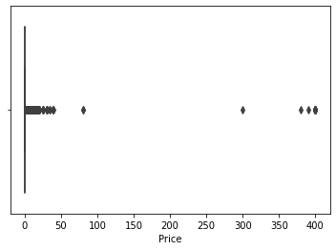

In [72]:

df.describe()

Out[72]:

|  | **Rating** | **Reviews** | **Installs** | **Price** |
| --- | --- | --- | --- | --- |
| **count** | 7717.000000 | 7.717000e+03 | 7.717000e+03 | 7717.000000 |
| **mean** | 4.173293 | 2.951275e+05 | 8.430620e+06 | 1.128725 |
| **std** | 0.544362 | 1.864640e+06 | 5.017636e+07 | 17.414784 |
| **min** | 1.000000 | 1.000000e+00 | 5.000000e+00 | 0.000000 |
| **25%** | 4.000000 | 1.090000e+02 | 1.000000e+04 | 0.000000 |
| **50%** | 4.300000 | 2.351000e+03 | 1.000000e+05 | 0.000000 |
| **75%** | 4.500000 | 3.910900e+04 | 1.000000e+06 | 0.000000 |
| **max** | 5.000000 | 4.489389e+07 | 1.000000e+09 | 400.000000 |

In [73]:

*#Boxplot for Reviews*

In [74]:

sns.boxplot(df['Reviews'])

Out[74]:

<AxesSubplot:xlabel='Reviews'>

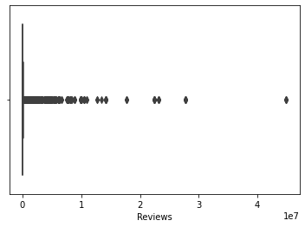

In [75]:

Q1=1.090000e+02

Q3=3.910900e+04

IQR=Q3-Q1

print('Q1 value:',Q1)

print('Q3 value:',Q3)

print(IQR)

outliers=df[(df['Reviews']>Q3+1.5*IQR)|(df['Reviews']<Q1-1.5*IQR)]

print(outliers)

Q1 value: 109.0

Q3 value: 39109.0

39000.0

App Category \

3 Sketch - Draw & Paint ART_AND_DESIGN

18 FlipaClip - Cartoon animation ART_AND_DESIGN

19 ibis Paint X ART_AND_DESIGN

45 Canva: Poster, banner, card maker & graphic de... ART_AND_DESIGN

70 Fines of the State Traffic Safety Inspectorate... AUTO_AND_VEHICLES

... ... ...

10740 PhotoFunia PHOTOGRAPHY

10781 Modern Strike Online GAME

10784 Big Hunter GAME

10809 Castle Clash: RPG War and Strategy FR FAMILY

10840 iHoroscope - 2018 Daily Horoscope & Astrology LIFESTYLE

Rating Reviews Size Installs Type Price Content Rating \

3 4.5 215644 25000 50000000 Free 0.0 Teen

18 4.3 194216 39000 5000000 Free 0.0 Everyone

19 4.6 224399 31000 10000000 Free 0.0 Everyone

45 4.7 174531 24000 10000000 Free 0.0 Everyone

70 4.8 116986 35000 5000000 Free 0.0 Everyone

... ... ... ... ... ... ... ...

10740 4.3 316378 4400 10000000 Free 0.0 Everyone

10781 4.3 834117 44000 10000000 Free 0.0 Teen

10784 4.3 245455 84000 10000000 Free 0.0 Everyone 10+

10809 4.7 376223 24000 1000000 Free 0.0 Everyone

10840 4.5 398307 19000 10000000 Free 0.0 Everyone

Genres Last Updated Current Ver Android Ver

3 Art & Design June 8, 2018 Varies with device 4.2 and up

18 Art & Design August 3, 2018 2.2.5 4.0.3 and up

19 Art & Design July 30, 2018 5.5.4 4.1 and up

45 Art & Design July 31, 2018 1.6.1 4.1 and up

70 Auto & Vehicles August 2, 2018 1.9.7 4.0.3 and up

... ... ... ... ...

10740 Photography June 3, 2017 4.0.7.0 2.3 and up

10781 Action July 30, 2018 1.25.4 4.1 and up

10784 Action May 31, 2018 2.8.6 4.0 and up

10809 Strategy July 18, 2018 1.4.2 4.1 and up

10840 Lifestyle July 25, 2018 Varies with device Varies with device

[1326 rows x 13 columns]

In [76]:

df1=sns.load_dataset('tips')

In [77]:

df1.describe()

Out[77]:

|  | **total_bill** | **tip** | **size** |
| --- | --- | --- | --- |
| **count** | 244.000000 | 244.000000 | 244.000000 |
| **mean** | 19.785943 | 2.998279 | 2.569672 |
| **std** | 8.902412 | 1.383638 | 0.951100 |
| **min** | 3.070000 | 1.000000 | 1.000000 |
| **25%** | 13.347500 | 2.000000 | 2.000000 |
| **50%** | 17.795000 | 2.900000 | 2.000000 |
| **75%** | 24.127500 | 3.562500 | 3.000000 |
| **max** | 50.810000 | 10.000000 | 6.000000 |

In [78]:

Q1=2.000000

Q3=3.562500

IQR=Q3-Q1

print('Q1 value:',Q1)

print('Q3 value:',Q3)

print(IQR)

outliers=df1[(df1['tip']>Q3+1.5*IQR)|(df1['tip']<Q1-1.5*IQR)]

print(outliers)

Q1 value: 2.0

Q3 value: 3.5625

1.5625

total_bill tip sex smoker day time size

23 39.42 7.58 Male No Sat Dinner 4

47 32.40 6.00 Male No Sun Dinner 4

59 48.27 6.73 Male No Sat Dinner 4

141 34.30 6.70 Male No Thur Lunch 6

170 50.81 10.00 Male Yes Sat Dinner 3

183 23.17 6.50 Male Yes Sun Dinner 4

212 48.33 9.00 Male No Sat Dinner 4

214 28.17 6.50 Female Yes Sat Dinner 3

239 29.03 5.92 Male No Sat Dinner 3

In [79]:

*#histogram for rating*

In [80]:

**import** **matplotlib.pyplot** **as** **plt**

In [81]:

plt.hist(df['Rating'])

Out[81]:

(array([ 17., 18., 39., 72., 132., 408., 781., 1406., 3212.,

1632.]),

array([1. , 1.4, 1.8, 2.2, 2.6, 3. , 3.4, 3.8, 4.2, 4.6, 5. ]),

<BarContainer object of 10 artists>)

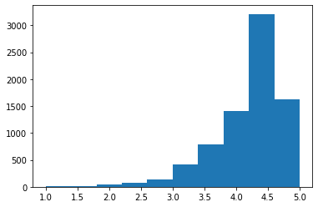

In [82]:

*#histogram for size*

plt.hist(df['Size'])

Out[82]:

(array([3245., 1398., 991., 606., 449., 325., 226., 161., 117.,

199.]),

array([8.500000e+00, 1.000765e+04, 2.000680e+04, 3.000595e+04,

4.000510e+04, 5.000425e+04, 6.000340e+04, 7.000255e+04,

8.000170e+04, 9.000085e+04, 1.000000e+05]),

<BarContainer object of 10 artists>)

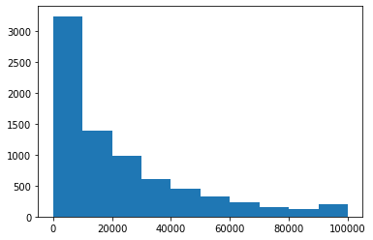

In [83]:

*#Apps with price more than $200*

df[df.Price>200]

Out[83]:

|  | **App** | **Category** | **Rating** | **Reviews** | **Size** | **Installs** | **Type** | **Price** | **Content Rating** | **Genres** | **Last Updated** | **Current Ver** | **Android Ver** |
| --- | --- | --- | --- | --- | --- | --- | --- | --- | --- | --- | --- | --- | --- |
| **4197** | most expensive app (H) | FAMILY | 4.3 | 6 | 1500 | 100 | Paid | 399.99 | Everyone | Entertainment | July 16, 2018 | 1.0 | 7.0 and up |
| **4362** | 💎 I'm rich | LIFESTYLE | 3.8 | 718 | 26000 | 10000 | Paid | 399.99 | Everyone | Lifestyle | March 11, 2018 | 1.0.0 | 4.4 and up |
| **4367** | I'm Rich - Trump Edition | LIFESTYLE | 3.6 | 275 | 7300 | 10000 | Paid | 400.00 | Everyone | Lifestyle | May 3, 2018 | 1.0.1 | 4.1 and up |
| **5351** | I am rich | LIFESTYLE | 3.8 | 3547 | 1800 | 100000 | Paid | 399.99 | Everyone | Lifestyle | January 12, 2018 | 2.0 | 4.0.3 and up |
| **5354** | I am Rich Plus | FAMILY | 4.0 | 856 | 8700 | 10000 | Paid | 399.99 | Everyone | Entertainment | May 19, 2018 | 3.0 | 4.4 and up |
| **5355** | I am rich VIP | LIFESTYLE | 3.8 | 411 | 2600 | 10000 | Paid | 299.99 | Everyone | Lifestyle | July 21, 2018 | 1.1.1 | 4.3 and up |
| **5356** | I Am Rich Premium | FINANCE | 4.1 | 1867 | 4700 | 50000 | Paid | 399.99 | Everyone | Finance | November 12, 2017 | 1.6 | 4.0 and up |
| **5357** | I am extremely Rich | LIFESTYLE | 2.9 | 41 | 2900 | 1000 | Paid | 379.99 | Everyone | Lifestyle | July 1, 2018 | 1.0 | 4.0 and up |
| **5358** | I am Rich! | FINANCE | 3.8 | 93 | 22000 | 1000 | Paid | 399.99 | Everyone | Finance | December 11, 2017 | 1.0 | 4.1 and up |
| **5359** | I am rich(premium) | FINANCE | 3.5 | 472 | 965 | 5000 | Paid | 399.99 | Everyone | Finance | May 1, 2017 | 3.4 | 4.4 and up |
| **5362** | I Am Rich Pro | FAMILY | 4.4 | 201 | 2700 | 5000 | Paid | 399.99 | Everyone | Entertainment | May 30, 2017 | 1.54 | 1.6 and up |
| **5364** | I am rich (Most expensive app) | FINANCE | 4.1 | 129 | 2700 | 1000 | Paid | 399.99 | Teen | Finance | December 6, 2017 | 2 | 4.0.3 and up |
| **5366** | I Am Rich | FAMILY | 3.6 | 217 | 4900 | 10000 | Paid | 389.99 | Everyone | Entertainment | June 22, 2018 | 1.5 | 4.2 and up |
| **5369** | I am Rich | FINANCE | 4.3 | 180 | 3800 | 5000 | Paid | 399.99 | Everyone | Finance | March 22, 2018 | 1.0 | 4.2 and up |
| **5373** | I AM RICH PRO PLUS | FINANCE | 4.0 | 36 | 41000 | 1000 | Paid | 399.99 | Everyone | Finance | June 25, 2018 | 1.0.2 | 4.1 and up |

In [84]:

*#to drop junk apps with price more than $200*

df=df.drop(index=df[df.Price>200].index)

In [85]:

df

Out[85]:

|  | **App** | **Category** | **Rating** | **Reviews** | **Size** | **Installs** | **Type** | **Price** | **Content Rating** | **Genres** | **Last Updated** | **Current Ver** | **Android Ver** |
| --- | --- | --- | --- | --- | --- | --- | --- | --- | --- | --- | --- | --- | --- |
| **0** | Photo Editor & Candy Camera & Grid & ScrapBook | ART_AND_DESIGN | 4.1 | 159 | 19000 | 10000 | Free | 0.0 | Everyone | Art & Design | January 7, 2018 | 1.0.0 | 4.0.3 and up |
| **1** | Coloring book moana | ART_AND_DESIGN | 3.9 | 967 | 14000 | 500000 | Free | 0.0 | Everyone | Art & Design;Pretend Play | January 15, 2018 | 2.0.0 | 4.0.3 and up |
| **2** | U Launcher Lite – FREE Live Cool Themes, Hide ... | ART_AND_DESIGN | 4.7 | 87510 | 8700 | 5000000 | Free | 0.0 | Everyone | Art & Design | August 1, 2018 | 1.2.4 | 4.0.3 and up |
| **3** | Sketch - Draw & Paint | ART_AND_DESIGN | 4.5 | 215644 | 25000 | 50000000 | Free | 0.0 | Teen | Art & Design | June 8, 2018 | Varies with device | 4.2 and up |
| **4** | Pixel Draw - Number Art Coloring Book | ART_AND_DESIGN | 4.3 | 967 | 2800 | 100000 | Free | 0.0 | Everyone | Art & Design;Creativity | June 20, 2018 | 1.1 | 4.4 and up |
| **...** | ... | ... | ... | ... | ... | ... | ... | ... | ... | ... | ... | ... | ... |
| **10833** | Chemin (fr) | BOOKS_AND_REFERENCE | 4.8 | 44 | 619 | 1000 | Free | 0.0 | Everyone | Books & Reference | March 23, 2014 | 0.8 | 2.2 and up |
| **10834** | FR Calculator | FAMILY | 4.0 | 7 | 2600 | 500 | Free | 0.0 | Everyone | Education | June 18, 2017 | 1.0.0 | 4.1 and up |
| **10836** | Sya9a Maroc - FR | FAMILY | 4.5 | 38 | 53000 | 5000 | Free | 0.0 | Everyone | Education | July 25, 2017 | 1.48 | 4.1 and up |
| **10837** | Fr. Mike Schmitz Audio Teachings | FAMILY | 5.0 | 4 | 3600 | 100 | Free | 0.0 | Everyone | Education | July 6, 2018 | 1.0 | 4.1 and up |
| **10840** | iHoroscope - 2018 Daily Horoscope & Astrology | LIFESTYLE | 4.5 | 398307 | 19000 | 10000000 | Free | 0.0 | Everyone | Lifestyle | July 25, 2018 | Varies with device | Varies with device |

7702 rows × 13 columns

In [86]:

*#Apps with more than 2 million reviews*

df[df.Reviews>2000000]

Out[86]:

|  | **App** | **Category** | **Rating** | **Reviews** | **Size** | **Installs** | **Type** | **Price** | **Content Rating** | **Genres** | **Last Updated** | **Current Ver** | **Android Ver** |
| --- | --- | --- | --- | --- | --- | --- | --- | --- | --- | --- | --- | --- | --- |
| **345** | Yahoo Mail – Stay Organized | COMMUNICATION | 4.3 | 4187998 | 16000 | 100000000 | Free | 0.0 | Everyone | Communication | July 18, 2018 | 5.29.3 | 4.4 and up |
| **347** | imo free video calls and chat | COMMUNICATION | 4.3 | 4785892 | 11000 | 500000000 | Free | 0.0 | Everyone | Communication | June 8, 2018 | 9.8.000000010501 | 4.0 and up |
| **366** | UC Browser Mini -Tiny Fast Private & Secure | COMMUNICATION | 4.4 | 3648120 | 3300 | 100000000 | Free | 0.0 | Teen | Communication | July 18, 2018 | 11.4.0 | 4.0 and up |
| **378** | UC Browser - Fast Download Private & Secure | COMMUNICATION | 4.5 | 17712922 | 40000 | 500000000 | Free | 0.0 | Teen | Communication | August 2, 2018 | 12.8.5.1121 | 4.0 and up |
| **383** | imo free video calls and chat | COMMUNICATION | 4.3 | 4785988 | 11000 | 500000000 | Free | 0.0 | Everyone | Communication | June 8, 2018 | 9.8.000000010501 | 4.0 and up |
| **...** | ... | ... | ... | ... | ... | ... | ... | ... | ... | ... | ... | ... | ... |
| **9142** | Need for Speed™ No Limits | GAME | 4.4 | 3344300 | 22000 | 50000000 | Free | 0.0 | Everyone 10+ | Racing | July 24, 2018 | 2.12.1 | 4.1 and up |
| **9166** | Modern Combat 5: eSports FPS | GAME | 4.3 | 2903386 | 58000 | 100000000 | Free | 0.0 | Mature 17+ | Action | July 24, 2018 | 3.2.1c | 4.0 and up |
| **10186** | Farm Heroes Saga | FAMILY | 4.4 | 7615646 | 71000 | 100000000 | Free | 0.0 | Everyone | Casual | August 7, 2018 | 5.2.6 | 2.3 and up |
| **10190** | Fallout Shelter | FAMILY | 4.6 | 2721923 | 25000 | 10000000 | Free | 0.0 | Teen | Simulation | June 11, 2018 | 1.13.12 | 4.1 and up |
| **10327** | Garena Free Fire | GAME | 4.5 | 5534114 | 53000 | 100000000 | Free | 0.0 | Teen | Action | August 3, 2018 | 1.21.0 | 4.0.3 and up |

219 rows × 13 columns

In [87]:

*#Drop records having more than 2 million reviews.*

In [88]:

df[df.Reviews>2000000].index

Out[88]:

Int64Index([ 345, 347, 366, 378, 383, 395, 413, 419, 420,

452,

...

8399, 8445, 8894, 8896, 9140, 9142, 9166, 10186, 10190,

10327],

dtype='int64', length=219)

In [89]:

df=df.drop(index=df[df.Reviews>2000000].index)

In [90]:

df

Out[90]:

|  | **App** | **Category** | **Rating** | **Reviews** | **Size** | **Installs** | **Type** | **Price** | **Content Rating** | **Genres** | **Last Updated** | **Current Ver** | **Android Ver** |
| --- | --- | --- | --- | --- | --- | --- | --- | --- | --- | --- | --- | --- | --- |
| **0** | Photo Editor & Candy Camera & Grid & ScrapBook | ART_AND_DESIGN | 4.1 | 159 | 19000 | 10000 | Free | 0.0 | Everyone | Art & Design | January 7, 2018 | 1.0.0 | 4.0.3 and up |
| **1** | Coloring book moana | ART_AND_DESIGN | 3.9 | 967 | 14000 | 500000 | Free | 0.0 | Everyone | Art & Design;Pretend Play | January 15, 2018 | 2.0.0 | 4.0.3 and up |
| **2** | U Launcher Lite – FREE Live Cool Themes, Hide ... | ART_AND_DESIGN | 4.7 | 87510 | 8700 | 5000000 | Free | 0.0 | Everyone | Art & Design | August 1, 2018 | 1.2.4 | 4.0.3 and up |
| **3** | Sketch - Draw & Paint | ART_AND_DESIGN | 4.5 | 215644 | 25000 | 50000000 | Free | 0.0 | Teen | Art & Design | June 8, 2018 | Varies with device | 4.2 and up |
| **4** | Pixel Draw - Number Art Coloring Book | ART_AND_DESIGN | 4.3 | 967 | 2800 | 100000 | Free | 0.0 | Everyone | Art & Design;Creativity | June 20, 2018 | 1.1 | 4.4 and up |
| **...** | ... | ... | ... | ... | ... | ... | ... | ... | ... | ... | ... | ... | ... |
| **10833** | Chemin (fr) | BOOKS_AND_REFERENCE | 4.8 | 44 | 619 | 1000 | Free | 0.0 | Everyone | Books & Reference | March 23, 2014 | 0.8 | 2.2 and up |
| **10834** | FR Calculator | FAMILY | 4.0 | 7 | 2600 | 500 | Free | 0.0 | Everyone | Education | June 18, 2017 | 1.0.0 | 4.1 and up |
| **10836** | Sya9a Maroc - FR | FAMILY | 4.5 | 38 | 53000 | 5000 | Free | 0.0 | Everyone | Education | July 25, 2017 | 1.48 | 4.1 and up |
| **10837** | Fr. Mike Schmitz Audio Teachings | FAMILY | 5.0 | 4 | 3600 | 100 | Free | 0.0 | Everyone | Education | July 6, 2018 | 1.0 | 4.1 and up |
| **10840** | iHoroscope - 2018 Daily Horoscope & Astrology | LIFESTYLE | 4.5 | 398307 | 19000 | 10000000 | Free | 0.0 | Everyone | Lifestyle | July 25, 2018 | Varies with device | Varies with device |

7483 rows × 13 columns

In [91]:

df.index

Out[91]:

Int64Index([ 0, 1, 2, 3, 4, 5, 6, 7, 8,

9,

...

10827, 10828, 10829, 10830, 10832, 10833, 10834, 10836, 10837,

10840],

dtype='int64', length=7483)

In [92]:

*#Boxplot for Installs*

sns.boxplot(df['Installs'])

Out[92]:

<AxesSubplot:xlabel='Installs'>

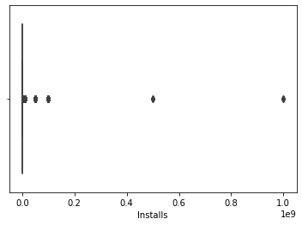

In [93]:

df.describe()

Out[93]:

|  | **Rating** | **Reviews** | **Installs** | **Price** |
| --- | --- | --- | --- | --- |
| **count** | 7483.000000 | 7.483000e+03 | 7.483000e+03 | 7483.000000 |
| **mean** | 4.165789 | 7.260651e+04 | 3.947465e+06 | 0.379595 |
| **std** | 0.549946 | 2.123720e+05 | 2.781831e+07 | 2.381384 |
| **min** | 1.000000 | 1.000000e+00 | 5.000000e+00 | 0.000000 |
| **25%** | 4.000000 | 9.900000e+01 | 1.000000e+04 | 0.000000 |
| **50%** | 4.300000 | 2.026000e+03 | 1.000000e+05 | 0.000000 |
| **75%** | 4.500000 | 3.238600e+04 | 1.000000e+06 | 0.000000 |
| **max** | 5.000000 | 1.986068e+06 | 1.000000e+09 | 79.990000 |

In [94]:

df['Installs'].quantile(0.25)

Out[94]:

10000.0

In [95]:

df['Installs'].quantile(0.10)

Out[95]:

1000.0

In [96]:

df['Installs'].quantile(0.50)

Out[96]:

100000.0

In [97]:

df['Installs'].quantile(0.70)

Out[97]:

1000000.0

In [98]:

df['Installs'].quantile(0.90)

Out[98]:

10000000.0

In [99]:

df['Installs'].quantile(0.95)

Out[99]:

10000000.0

In [100]:

df['Installs'].quantile(0.99)

Out[100]:

50000000.0

In [101]:

Q1=1.000000e+04

Q3=1.000000e+06

IQR=Q3-Q1

print(Q1)

print(Q3)

print(IQR)

outliers=df[(df['Installs']>Q3+1.5*IQR)|(df['Installs']<Q1-1.5*IQR)]

print(outliers)

10000.0

1000000.0

990000.0

App Category \

2 U Launcher Lite – FREE Live Cool Themes, Hide ... ART_AND_DESIGN

3 Sketch - Draw & Paint ART_AND_DESIGN

12 Tattoo Name On My Photo Editor ART_AND_DESIGN

18 FlipaClip - Cartoon animation ART_AND_DESIGN

19 ibis Paint X ART_AND_DESIGN

... ... ...

10731 FeaturePoints: Free Gift Cards FAMILY

10740 PhotoFunia PHOTOGRAPHY

10781 Modern Strike Online GAME

10784 Big Hunter GAME

10840 iHoroscope - 2018 Daily Horoscope & Astrology LIFESTYLE

Rating Reviews Size Installs Type Price Content Rating \

2 4.7 87510 8700 5000000 Free 0.0 Everyone

3 4.5 215644 25000 50000000 Free 0.0 Teen

12 4.2 44829 20000 10000000 Free 0.0 Teen

18 4.3 194216 39000 5000000 Free 0.0 Everyone

19 4.6 224399 31000 10000000 Free 0.0 Everyone

... ... ... ... ... ... ... ...

10731 3.9 121321 46000 5000000 Free 0.0 Everyone

10740 4.3 316378 4400 10000000 Free 0.0 Everyone

10781 4.3 834117 44000 10000000 Free 0.0 Teen

10784 4.3 245455 84000 10000000 Free 0.0 Everyone 10+

10840 4.5 398307 19000 10000000 Free 0.0 Everyone

Genres Last Updated Current Ver Android Ver

2 Art & Design August 1, 2018 1.2.4 4.0.3 and up

3 Art & Design June 8, 2018 Varies with device 4.2 and up

12 Art & Design April 2, 2018 3.8 4.1 and up

18 Art & Design August 3, 2018 2.2.5 4.0.3 and up

19 Art & Design July 30, 2018 5.5.4 4.1 and up

... ... ... ... ...

10731 Entertainment October 22, 2016 8.7 4.0.3 and up

10740 Photography June 3, 2017 4.0.7.0 2.3 and up

10781 Action July 30, 2018 1.25.4 4.1 and up

10784 Action May 31, 2018 2.8.6 4.0 and up

10840 Lifestyle July 25, 2018 Varies with device Varies with device

[1529 rows x 13 columns]

In [102]:

*#max value 100000000 is considere as cutoff for outlier and drop records having values more than that*

In [103]:

df[df.Installs>100000000]

Out[103]:

|  | **App** | **Category** | **Rating** | **Reviews** | **Size** | **Installs** | **Type** | **Price** | **Content Rating** | **Genres** | **Last Updated** | **Current Ver** | **Android Ver** |
| --- | --- | --- | --- | --- | --- | --- | --- | --- | --- | --- | --- | --- | --- |
| **3473** | Dropbox | PRODUCTIVITY | 4.4 | 1861310 | 61000 | 500000000 | Free | 0.0 | Everyone | Productivity | August 1, 2018 | Varies with device | Varies with device |
| **3569** | Dropbox | PRODUCTIVITY | 4.4 | 1861309 | 61000 | 500000000 | Free | 0.0 | Everyone | Productivity | August 1, 2018 | Varies with device | Varies with device |
| **3736** | Google News | NEWS_AND_MAGAZINES | 3.9 | 877635 | 13000 | 1000000000 | Free | 0.0 | Teen | News & Magazines | August 1, 2018 | 5.2.0 | 4.4 and up |
| **3765** | Google News | NEWS_AND_MAGAZINES | 3.9 | 877635 | 13000 | 1000000000 | Free | 0.0 | Teen | News & Magazines | August 1, 2018 | 5.2.0 | 4.4 and up |
| **3816** | Google News | NEWS_AND_MAGAZINES | 3.9 | 877643 | 13000 | 1000000000 | Free | 0.0 | Teen | News & Magazines | August 1, 2018 | 5.2.0 | 4.4 and up |
| **4048** | Dropbox | PRODUCTIVITY | 4.4 | 1860844 | 61000 | 500000000 | Free | 0.0 | Everyone | Productivity | August 1, 2018 | Varies with device | Varies with device |
| **5596** | Samsung Health | HEALTH_AND_FITNESS | 4.3 | 480208 | 70000 | 500000000 | Free | 0.0 | Everyone | Health & Fitness | July 31, 2018 | 5.17.2.009 | 5.0 and up |
| **9844** | Google News | NEWS_AND_MAGAZINES | 3.9 | 878065 | 13000 | 1000000000 | Free | 0.0 | Teen | News & Magazines | August 1, 2018 | 5.2.0 | 4.4 and up |

In [104]:

*#Decide a threshold as cutoff for outlier and drop records having values more than that*

In [105]:

df[df.Installs>100000000].index

Out[105]:

Int64Index([3473, 3569, 3736, 3765, 3816, 4048, 5596, 9844], dtype='int64')

In [106]:

df=df.drop(index=df[df.Installs>100000000].index)

In [107]:

df.index

Out[107]:

Int64Index([ 0, 1, 2, 3, 4, 5, 6, 7, 8,

9,

...

10827, 10828, 10829, 10830, 10832, 10833, 10834, 10836, 10837,

10840],

dtype='int64', length=7475)

In [ ]:

In [108]:

*#Bivariate Analysis*

In [109]:

*#Scatter plot for Rating vs Price*

plt.scatter(df['Price'],df['Rating'])

plt.xlabel('Price')

plt.ylabel('Rating')

plt.title('Rating vs Price')

Out[109]:

Text(0.5, 1.0, 'Rating vs Price')

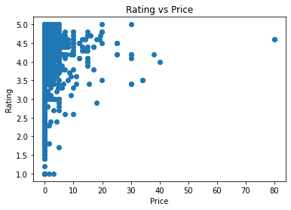

In [110]:

*#No, Rating doesn't increase with price*

In [111]:

*#Scatter plot for Rating vs Size*

In [112]:

plt.scatter(df['Size'],df['Rating'])

plt.xlabel('Size')

plt.ylabel('Rating')

Out[112]:

Text(0, 0.5, 'Rating')

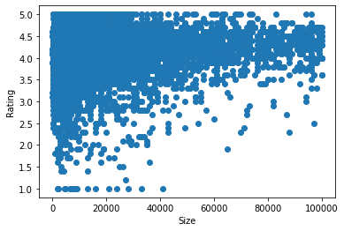

In [113]:

*# No it coudn't prove heavier apps are always rated better*

In [114]:

*#Scatter plot for Rating vs Reviews*

In [115]:

plt.scatter(df['Rating'],df['Reviews'])

Out[115]:

<matplotlib.collections.PathCollection at 0x7f7e72cab8d0>

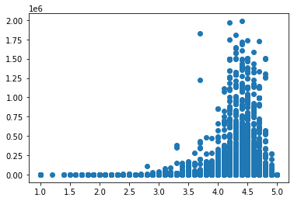

In [116]:

*#No, it doesn't proves more review means a better rating always.*

In [117]:

*#boxplot for Rating vs Content rating*

In [118]:

sns.boxplot(df['Rating'],df['Content Rating'])

Out[118]:

<AxesSubplot:xlabel='Rating', ylabel='Content Rating'>

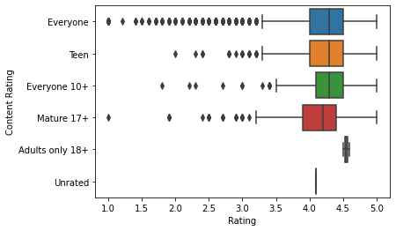

In [119]:

*#Everyone type of apps are liked better by the users.*

In [120]:

*#boxplot for Ratings vs Category*

In [121]:

sns.boxplot(df['Rating'],df['Category'])

Out[121]:

<AxesSubplot:xlabel='Rating', ylabel='Category'>

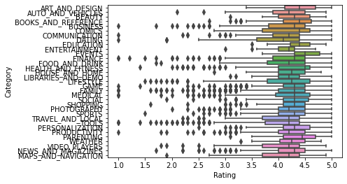

In [122]:

df['Installs'].describe()

Out[122]:

count 7.475000e+03

mean 3.149014e+06

std 1.055387e+07

min 5.000000e+00

25% 1.000000e+04

50% 1.000000e+05

75% 1.000000e+06

max 1.000000e+08

Name: Installs, dtype: float64

In [123]:

sns.boxplot(df['Installs'])

Out[123]:

<AxesSubplot:xlabel='Installs'>

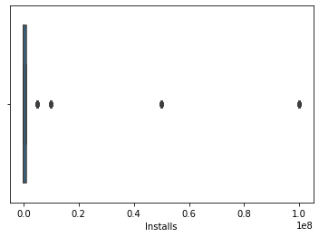

In [124]:

sns.boxplot(df['Rating'])

Out[124]:

<AxesSubplot:xlabel='Rating'>

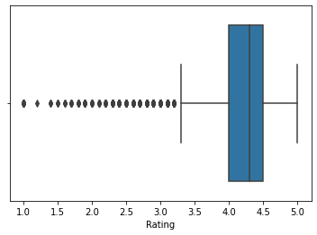

In [125]:

df.index

Out[125]:

Int64Index([ 0, 1, 2, 3, 4, 5, 6, 7, 8,

9,

...

10827, 10828, 10829, 10830, 10832, 10833, 10834, 10836, 10837,

10840],

dtype='int64', length=7475)

In [126]:

*#8.Data preprocessing*

In [127]:

inp1=df.copy()

In [128]:

inp1.shape

Out[128]:

(7475, 13)

In [129]:

sns.boxplot(inp1.Reviews)

Out[129]:

<AxesSubplot:xlabel='Reviews'>

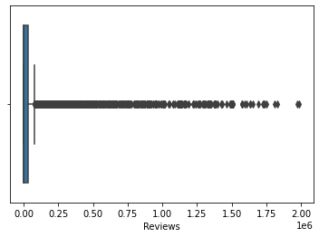

In [130]:

inp1.Reviews.describe()

Out[130]:

count 7.475000e+03

mean 7.140332e+04

std 2.085558e+05

min 1.000000e+00

25% 9.850000e+01

50% 2.014000e+03

75% 3.229900e+04

max 1.986068e+06

Name: Reviews, dtype: float64

In [131]:

sns.distplot(inp1.Reviews)

Out[131]:

<AxesSubplot:xlabel='Reviews'>

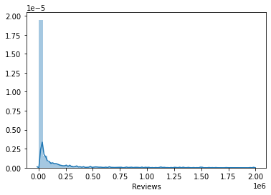

In [132]:

inp1.Reviews=inp1.Reviews.apply(np.log1p)

In [133]:

inp1.shape

Out[133]:

(7475, 13)

In [134]:

inp1.Reviews.describe()

Out[134]:

count 7475.000000

mean 7.489245

std 3.482734

min 0.693147

25% 4.600145

50% 7.608374

75% 10.382822

max 14.501668

Name: Reviews, dtype: float64

In [135]:

sns.boxplot(df.Installs)

Out[135]:

<AxesSubplot:xlabel='Installs'>



In [136]:

inp1.Installs.describe()

Out[136]:

count 7.475000e+03

mean 3.149014e+06

std 1.055387e+07

min 5.000000e+00

25% 1.000000e+04

50% 1.000000e+05

75% 1.000000e+06

max 1.000000e+08

Name: Installs, dtype: float64

In [137]:

inp1.Installs=inp1.Installs.apply(np.log1p)

In [138]:

inp1.Installs.describe()

Out[138]:

count 7475.000000

mean 11.457308

std 3.536551

min 1.791759

25% 9.210440

50% 11.512935

75% 13.815512

max 18.420681

Name: Installs, dtype: float64

In [139]:

*#Drop columns App, Last Updated, Current Ver, and Android Ver. These variables are not useful for our task.*

In [140]:

inp1.columns

Out[140]:

Index(['App', 'Category', 'Rating', 'Reviews', 'Size', 'Installs', 'Type',

'Price', 'Content Rating', 'Genres', 'Last Updated', 'Current Ver',

'Android Ver'],

dtype='object')

In [141]:

inp1.head()

Out[141]:

|  | **App** | **Category** | **Rating** | **Reviews** | **Size** | **Installs** | **Type** | **Price** | **Content Rating** | **Genres** | **Last Updated** | **Current Ver** | **Android Ver** |
| --- | --- | --- | --- | --- | --- | --- | --- | --- | --- | --- | --- | --- | --- |
| **0** | Photo Editor & Candy Camera & Grid & ScrapBook | ART_AND_DESIGN | 4.1 | 5.075174 | 19000 | 9.210440 | Free | 0.0 | Everyone | Art & Design | January 7, 2018 | 1.0.0 | 4.0.3 and up |
| **1** | Coloring book moana | ART_AND_DESIGN | 3.9 | 6.875232 | 14000 | 13.122365 | Free | 0.0 | Everyone | Art & Design;Pretend Play | January 15, 2018 | 2.0.0 | 4.0.3 and up |
| **2** | U Launcher Lite – FREE Live Cool Themes, Hide ... | ART_AND_DESIGN | 4.7 | 11.379520 | 8700 | 15.424949 | Free | 0.0 | Everyone | Art & Design | August 1, 2018 | 1.2.4 | 4.0.3 and up |
| **3** | Sketch - Draw & Paint | ART_AND_DESIGN | 4.5 | 12.281389 | 25000 | 17.727534 | Free | 0.0 | Teen | Art & Design | June 8, 2018 | Varies with device | 4.2 and up |
| **4** | Pixel Draw - Number Art Coloring Book | ART_AND_DESIGN | 4.3 | 6.875232 | 2800 | 11.512935 | Free | 0.0 | Everyone | Art & Design;Creativity | June 20, 2018 | 1.1 | 4.4 and up |

In [142]:

inp1=inp1.drop(['App','Last Updated','Current Ver','Android Ver'],axis=1)

In [143]:

inp1.columns

Out[143]:

Index(['Category', 'Rating', 'Reviews', 'Size', 'Installs', 'Type', 'Price',

'Content Rating', 'Genres'],

dtype='object')

In [144]:

*#To get dummies values for Category,Genres and Content Rating*

In [145]:

inp1_dummies=pd.get_dummies(inp1[['Category','Genres','Content Rating']])

In [146]:

inp1_dummies.head()

Out[146]:

|  | **Category_ART_AND_DESIGN** | **Category_AUTO_AND_VEHICLES** | **Category_BEAUTY** | **Category_BOOKS_AND_REFERENCE** | **Category_BUSINESS** | **Category_COMICS** | **Category_COMMUNICATION** | **Category_DATING** | **Category_EDUCATION** | **Category_ENTERTAINMENT** | **...** | **Genres_Video Players & Editors;Creativity** | **Genres_Video Players & Editors;Music & Video** | **Genres_Weather** | **Genres_Word** | **Content Rating_Adults only 18+** | **Content Rating_Everyone** | **Content Rating_Everyone 10+** | **Content Rating_Mature 17+** | **Content Rating_Teen** | **Content Rating_Unrated** |
| --- | --- | --- | --- | --- | --- | --- | --- | --- | --- | --- | --- | --- | --- | --- | --- | --- | --- | --- | --- | --- | --- |
| **0** | 1 | 0 | 0 | 0 | 0 | 0 | 0 | 0 | 0 | 0 | ... | 0 | 0 | 0 | 0 | 0 | 1 | 0 | 0 | 0 | 0 |
| **1** | 1 | 0 | 0 | 0 | 0 | 0 | 0 | 0 | 0 | 0 | ... | 0 | 0 | 0 | 0 | 0 | 1 | 0 | 0 | 0 | 0 |
| **2** | 1 | 0 | 0 | 0 | 0 | 0 | 0 | 0 | 0 | 0 | ... | 0 | 0 | 0 | 0 | 0 | 1 | 0 | 0 | 0 | 0 |
| **3** | 1 | 0 | 0 | 0 | 0 | 0 | 0 | 0 | 0 | 0 | ... | 0 | 0 | 0 | 0 | 0 | 0 | 0 | 0 | 1 | 0 |
| **4** | 1 | 0 | 0 | 0 | 0 | 0 | 0 | 0 | 0 | 0 | ... | 0 | 0 | 0 | 0 | 0 | 1 | 0 | 0 | 0 | 0 |

5 rows × 151 columns

In [147]:

inp1.head()

Out[147]:

|  | **Category** | **Rating** | **Reviews** | **Size** | **Installs** | **Type** | **Price** | **Content Rating** | **Genres** |
| --- | --- | --- | --- | --- | --- | --- | --- | --- | --- |
| **0** | ART_AND_DESIGN | 4.1 | 5.075174 | 19000 | 9.210440 | Free | 0.0 | Everyone | Art & Design |
| **1** | ART_AND_DESIGN | 3.9 | 6.875232 | 14000 | 13.122365 | Free | 0.0 | Everyone | Art & Design;Pretend Play |
| **2** | ART_AND_DESIGN | 4.7 | 11.379520 | 8700 | 15.424949 | Free | 0.0 | Everyone | Art & Design |
| **3** | ART_AND_DESIGN | 4.5 | 12.281389 | 25000 | 17.727534 | Free | 0.0 | Teen | Art & Design |
| **4** | ART_AND_DESIGN | 4.3 | 6.875232 | 2800 | 11.512935 | Free | 0.0 | Everyone | Art & Design;Creativity |

In [148]:

inp1_num=inp1[['Rating','Reviews','Size','Installs','Price','Type']]

In [149]:

inp1_num.head()

Out[149]:

|  | **Rating** | **Reviews** | **Size** | **Installs** | **Price** | **Type** |
| --- | --- | --- | --- | --- | --- | --- |
| **0** | 4.1 | 5.075174 | 19000 | 9.210440 | 0.0 | Free |
| **1** | 3.9 | 6.875232 | 14000 | 13.122365 | 0.0 | Free |
| **2** | 4.7 | 11.379520 | 8700 | 15.424949 | 0.0 | Free |
| **3** | 4.5 | 12.281389 | 25000 | 17.727534 | 0.0 | Free |
| **4** | 4.3 | 6.875232 | 2800 | 11.512935 | 0.0 | Free |

In [150]:

inp2=pd.concat([inp1_num,inp1_dummies],axis=1)

In [151]:

inp2.shape

Out[151]:

(7475, 157)

In [152]:

inp2.head()

Out[152]:

|  | **Rating** | **Reviews** | **Size** | **Installs** | **Price** | **Type** | **Category_ART_AND_DESIGN** | **Category_AUTO_AND_VEHICLES** | **Category_BEAUTY** | **Category_BOOKS_AND_REFERENCE** | **...** | **Genres_Video Players & Editors;Creativity** | **Genres_Video Players & Editors;Music & Video** | **Genres_Weather** | **Genres_Word** | **Content Rating_Adults only 18+** | **Content Rating_Everyone** | **Content Rating_Everyone 10+** | **Content Rating_Mature 17+** | **Content Rating_Teen** | **Content Rating_Unrated** |
| --- | --- | --- | --- | --- | --- | --- | --- | --- | --- | --- | --- | --- | --- | --- | --- | --- | --- | --- | --- | --- | --- |
| **0** | 4.1 | 5.075174 | 19000 | 9.210440 | 0.0 | Free | 1 | 0 | 0 | 0 | ... | 0 | 0 | 0 | 0 | 0 | 1 | 0 | 0 | 0 | 0 |
| **1** | 3.9 | 6.875232 | 14000 | 13.122365 | 0.0 | Free | 1 | 0 | 0 | 0 | ... | 0 | 0 | 0 | 0 | 0 | 1 | 0 | 0 | 0 | 0 |
| **2** | 4.7 | 11.379520 | 8700 | 15.424949 | 0.0 | Free | 1 | 0 | 0 | 0 | ... | 0 | 0 | 0 | 0 | 0 | 1 | 0 | 0 | 0 | 0 |
| **3** | 4.5 | 12.281389 | 25000 | 17.727534 | 0.0 | Free | 1 | 0 | 0 | 0 | ... | 0 | 0 | 0 | 0 | 0 | 0 | 0 | 0 | 1 | 0 |
| **4** | 4.3 | 6.875232 | 2800 | 11.512935 | 0.0 | Free | 1 | 0 | 0 | 0 | ... | 0 | 0 | 0 | 0 | 0 | 1 | 0 | 0 | 0 | 0 |

5 rows × 157 columns

In [153]:

*#To perform Linear Regression*

In [154]:

X = inp2[['Reviews', 'Size', 'Installs', 'Price']]

y = inp2[['Rating']]

In [155]:

**from** **sklearn.model_selection** **import** train_test_split

In [156]:

X_train, X_test, y_train, y_test = train_test_split(X,y, train_size = 0.7, random_state = 120)

In [157]:

print(X_train.shape)

print(X_test.shape)

print(y_train.shape)

print(y_test.shape)

(5232, 4)

(2243, 4)

(5232, 1)

(2243, 1)

In [158]:

X_train.head()

Out[158]:

|  | **Reviews** | **Size** | **Installs** | **Price** |
| --- | --- | --- | --- | --- |
| **6096** | 10.271355 | 6300 | 15.424949 | 0.00 |
| **4172** | 5.545177 | 1600 | 8.517393 | 14.99 |
| **1499** | 8.799662 | 5500 | 13.815512 | 0.00 |
| **2871** | 10.062242 | 30000 | 13.815512 | 0.00 |
| **6348** | 6.877296 | 3600 | 9.210440 | 0.00 |

In [159]:

**from** **sklearn.linear_model** **import** LinearRegression

lm = LinearRegression()

lm.fit(X_train, y_train)

Out[159]:

LinearRegression()

In [160]:

print(lm.coef_)

[[ 1.64124303e-01 -1.91747302e-07 -1.43029432e-01 -4.50065175e-03]]

In [161]:

print(lm.intercept_)

[4.58384813]

In [162]:

prediction = lm.predict(X_test)

print(prediction)

[[4.20366177]

[4.21542551]

[3.96471795]

...

[4.51791915]

[3.96765691]

[4.08091251]]

In [163]:

**from** **sklearn.metrics** **import** mean_squared_error, r2_score

In [164]:

mse = mean_squared_error(y_test,prediction)

print(mse)

0.2863659787311721

In [165]:

r_square = r2_score(y_test,prediction)

print(r_square)

0.10307459340283753

In [166]:

print('R square value is:',r_square)

print('Mean squared value is:',mse)

R square value is: 0.10307459340283753

Mean squared value is: 0.2863659787311721

In [167]:

**import** **pandas** **as** **pd**

In [168]:

inp2_new = pd.DataFrame({'Actual':[y_test],'Predicted':[prediction]})

inp2_new

Out[168]:

|  | **Actual** | **Predicted** |
| --- | --- | --- |
| **0** | Rating 8664 4.4 10155 4.2 4406... | [[4.203661771464269], [4.215425511384417], [3.... |

In [169]:

y

Out[169]:

|  | **Rating** |
| --- | --- |
| **0** | 4.1 |
| **1** | 3.9 |
| **2** | 4.7 |
| **3** | 4.5 |
| **4** | 4.3 |
| **...** | ... |
| **10833** | 4.8 |
| **10834** | 4.0 |
| **10836** | 4.5 |
| **10837** | 5.0 |
| **10840** | 4.5 |

7475 rows × 1 columns

In [170]:

prediction

Out[170]:

array([[4.20366177],

[4.21542551],

[3.96471795],

...,

[4.51791915],

[3.96765691],

[4.08091251]])

In [ ]:

Dataset contained many null values so our first step was to remove those rows with null values in it. Also the dataset contained many information that are irrelevant in predicting the rating of app. Thus, second step is to remove those unnecessary & unrelated column.

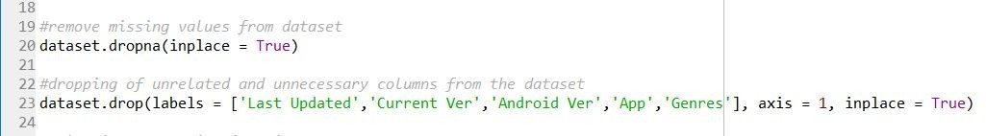

Categories column contains more than one value & also it was in the string format. For any machine learning model to be applied, dataset must be in the format of integers. So the next step is to clean the Category column.

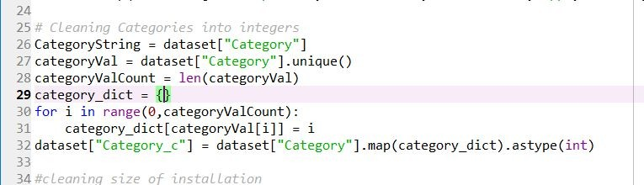

Next step is to clean the size of installation column as it contains the values in KB & MB, so converting the all the values in bytes will be much easier for the dataset to be processed under any machine learning model.

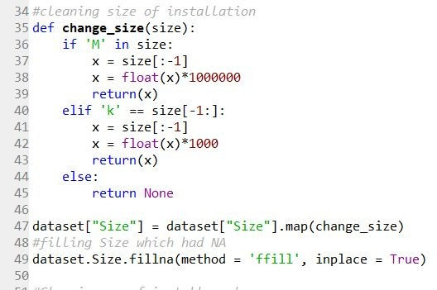

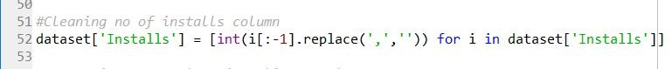Number of installs column contains the value in the form of x+ which denotes no of installs of said app is greater than x. Thus cleaning of installs column as-

Type of app denotes whether the app is free or paid which is binary values so, converting those values in 0 &1.

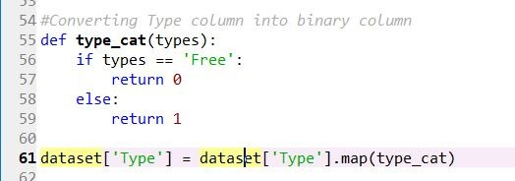

Also, Price column depicts the price of application on the play store, whose value is either 0 for free app & some amount in dollars for paid apps. Converting those amounts in float values as-

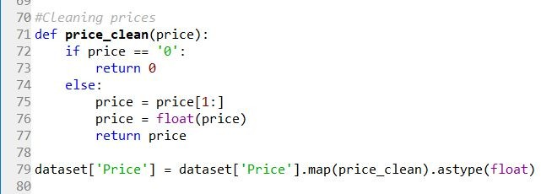

Now, the first step for any machine learning algorithm completes. Dataset is preprocessed & is ready to be applied on regression model.

# TRAINING & TESTING OF MODEL

For training of our selected models- Linear Regression,SVM, Random Forest Regression models.

## LINEAR REGRESSION

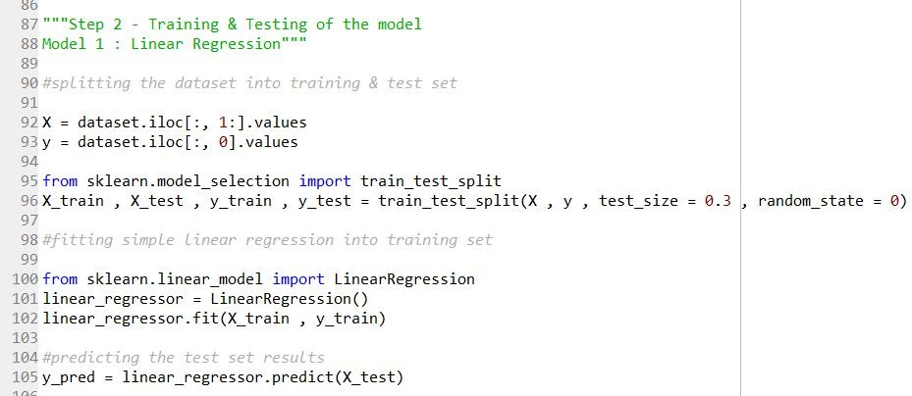

**SVM REGRESSION (With Feature Scaling)**

Firstly, Feature scaling is applied on the dataset in order to scale the data in all columns. Some machine learning algorithms uses Euclidean Distance between the features for training purpose. With wide range in the values of column, sometimes result gets purely dependent on the column with larger values.

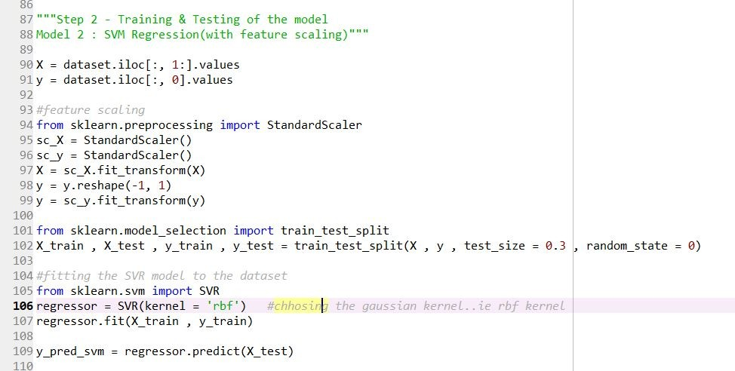

## SVM REGRESSION (Without Feature Scaling)

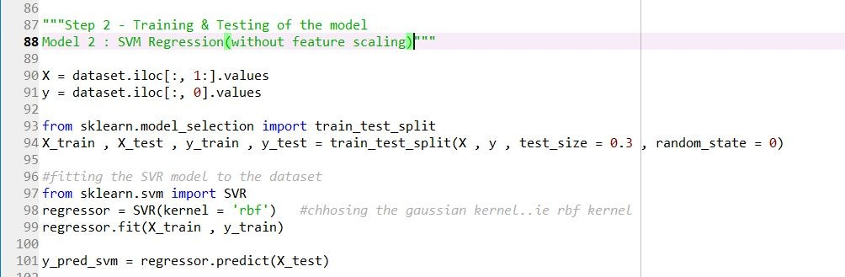

**RANDOM FOREST REGRESSION**

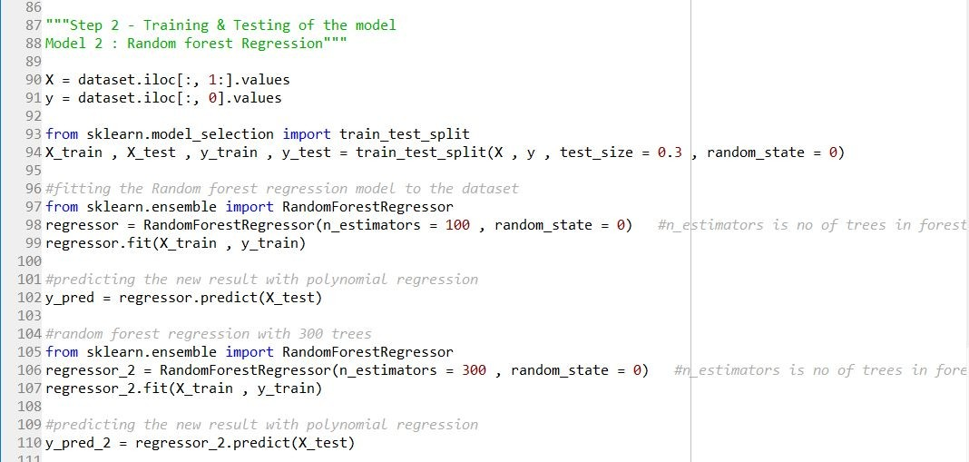

# RESULTS AND DISCUSSIONS

## LINEAR REGRESSION

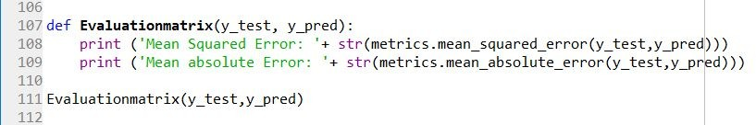

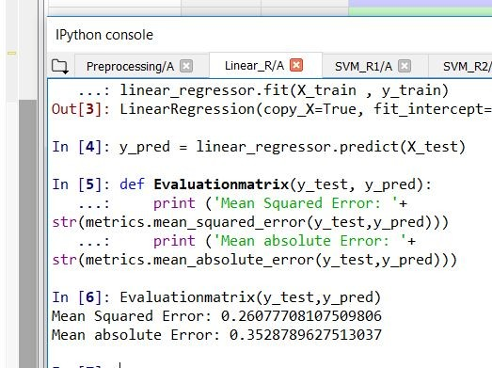

After the Linear regression model is trained, it is then tested on test set. Predicted results & actual results are compared using the evaluation parameter for regression model such as mean squared error & mean absolute error. As shown in the picture,

Mean squared error - 0.2607 Mean absolute error - 0.3528

## SVM REGRESSION (With Feature Scaling)

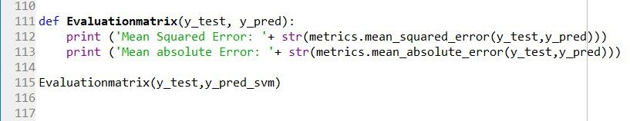

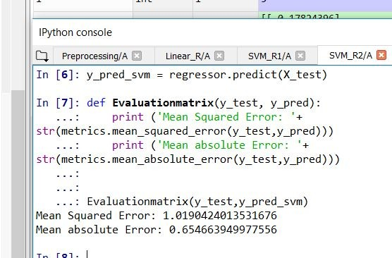

After the SVM model is trained, it is then tested on test set. Predicted results & actual results are compared using the evaluation parameter for regression model such as mean squared error & mean absolute error. In SVM model here, firstly feature scaling is used for scaling the all the values in columns. As shown in the picture,

Mean squared error - 1.0190 Mean absolute error - 0.6546

## SVM REGRESSION (Without Feature Scaling)

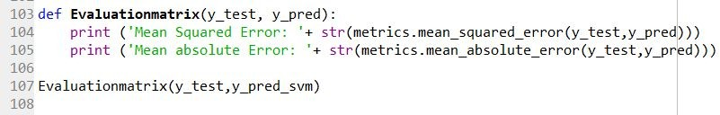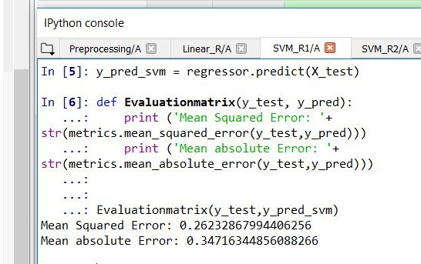

After the SVM model is trained, it is then tested on test set. Predicted results & actual results are compared using the evaluation parameter for regression model such as mean squared error & mean absolute error. In SVM model here, feature scaling is not used. As shown in the picture, Mean squared error - 0.2623

Mean absolute error - 0.3471

## RANDOM FOREST REGRESSION

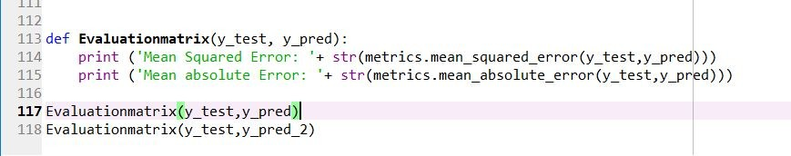

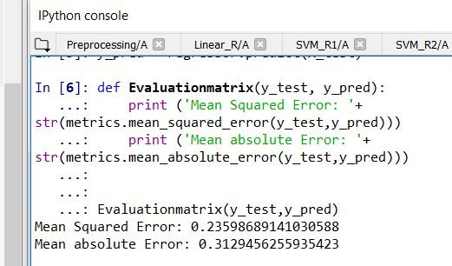

After the Random forest model is trained, it is then tested on test set. Predicted results & actual results are compared using the evaluation parameter for regression model such as mean squared error & mean absolute error. Regression model shown here is trained with 100 trees. As shown in the picture,

Mean squared error - 0.23598 Mean absolute error - 0.31294

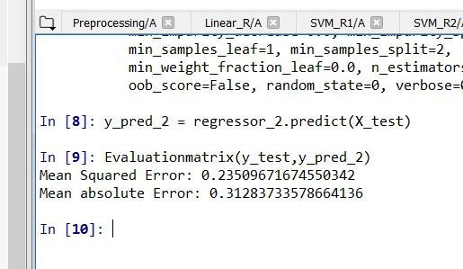

After the Random forest model is trained, it is then tested on test set. Predicted results & actual results are compared using the evaluation parameter for regression model such as mean squared error & mean absolute error. Regression model shown here is trained with 300 trees. As shown in the picture,

Mean squared error - 0.23509 Mean absolute error - 0.3128

# CONCLUSIONS

Results produced by all the models are-

## LINEAR REGRESSION

Mean squared error - 0.2607 Mean absolute error - 0.3528

## SVM REGRESSION (With Feature Scaling)

Mean squared error - 1.0190 Mean absolute error - 0.6546

## SVM REGRESSION (Without Feature Scaling)

Mean squared error - 0.2623 Mean absolute error - 0.3471

## RANDOM FOREST REGRESSION

**Trees = 100**

Mean squared error - 0.23598 Mean absolute error - 0.31294

## Trees = 300

Mean squared error - 0.23509 Mean absolute error - 0.3128

As observed from the results, Random forest regression model produces better results in comparison of other models. By increasing the no of trees(n_estimators parameter) in random forest regression, increases the performance and makes the predictions more stable. One of the big problems in machine learning is overfitting, but most of the time this won’t happen that easy to a random forest model. That’s because if there are enough trees in the forest, the regressor won’t overfit the model. The main limitation of Random Forest is that a large number of trees can make the algorithm to slow and ineffective for real-time predictions. In general, these algorithms are fast to train, but quite slow to create predictions once they are trained. A more accurate prediction requires more trees, which results in a slower model. In most real-world applications the random forest algorithm is fast enough, but there can certainly be situations where run-time performance is important and other approaches would be preferred.

# REFERENCES

1. [https://www.kaggle.com/lava18/google-play-store-apps](http://www.kaggle.com/lava18/google-play-store-apps)
2. [https://scikit-learn.org/stable/modules/generated/sklearn.linear_model.LinearRegression.](https://scikit-learn.org/stable/modules/generated/sklearn.linear_model.LinearRegression.html) [html](https://scikit-learn.org/stable/modules/generated/sklearn.linear_model.LinearRegression.html)
3. <https://scikit-learn.org/stable/modules/generated/sklearn.svm.SVR.html>
4. [https://scikit-learn.org/stable/modules/generated/sklearn.ensemble.RandomForestRegress](https://scikit-learn.org/stable/modules/generated/sklearn.ensemble.RandomForestRegressor.html) [or.html](https://scikit-learn.org/stable/modules/generated/sklearn.ensemble.RandomForestRegressor.html)
5. <https://scikit-learn.org/stable/modules/preprocessing.html>
6. <https://towardsdatascience.com/the-random-forest-algorithm-d457d499ffcd>